*Master-Thesis*

*/*

*Masterarbeit*

**A study on the modelling of the distribution automation systems using Petri Nets**

/

**Eine Untersuchung zur Modellierung der Verteilnetzautomationssysteme mit Petri Netz**

*Huiyuan Xiao*

*Studienrichtung:*

Systemtechnik und Automatisierung

Professor: Prof. Antonello Monti

Supervisor : Abhinav Sadu

Aachen, den\_\_\_\_\_\_\_\_\_\_\_\_\_ \_\_\_\_\_\_\_\_\_\_\_\_\_\_\_\_\_\_\_\_\_\_\_\_\_\_

Der 1. Prüfer

Aachen, den\_\_\_\_\_\_\_\_\_\_\_\_\_ \_\_\_\_\_\_\_\_\_\_\_\_\_\_\_\_\_\_\_\_\_\_\_\_\_\_

Der Vorsitzende des Prüfungsausschusses

**Table of Contents**

[1. Introduction 9](#_Toc380682386)

[1.1. Motivation 9](#_Toc380682387)

[1.2. Structure of Work 10](#_Toc380682388)

[2. Architecture of the IDE4L project 13](#_Toc380682389)

[3. Real-Time Power System Simulation 15](#_Toc380682390)

[3.1. Power System Simulation in Real Time Digital Simulator 15](#_Toc380682391)

[3.2. RTDS Hardware 15](#_Toc380682392)

[3.2.1. GTWIF 16](#_Toc380682393)

[3.2.2. GPC 16](#_Toc380682394)

[3.2.3. GTIO 16](#_Toc380682395)

[3.2.4. GTNET 18](#_Toc380682396)

[3.3. RTDS Software 18](#_Toc380682397)

[3.3.1. RSCAD Draft 18](#_Toc380682398)

[3.3.2. RSCAD Runtime 18](#_Toc380682399)

[3.4. Acquisition of Real-Time Measurements from RTDS 19](#_Toc380682400)

[3.5. Summary 20](#_Toc380682401)

[4. Synchrophasor Measurement System 21](#_Toc380682402)

[4.1. Principle of Phasor Measurement Unit (PMU) 21](#_Toc380682403)

[4.2. Setup for Commercial PMUs – Alstom MiCOM P847 22](#_Toc380682404)

[4.2.1. Time Tagging 23](#_Toc380682405)

[4.2.2. Analog and Digital measurement interfaces of MiCOM P847 23](#_Toc380682406)

[4.2.3. Processing of phasor and other functionalities 24](#_Toc380682407)

[4.3. Hardware Interface for Analog Signal Acquisition 25](#_Toc380682408)

[4.3.1. Structure 25](#_Toc380682409)

[4.3.2. Signal Conditioner 26](#_Toc380682410)

[4.4. NIcRIO PMU for Dynamic phasors 30](#_Toc380682411)

[4.5. Scaling of Phasor Measurements 31](#_Toc380682412)

[4.6. Synchrophasor Data Processing and Management – OpenPDC 31](#_Toc380682413)

[4.6.1. OpenPDC Architecture 32](#_Toc380682414)

[4.6.2. OpenPDC Configuration for Online Monitoring Systems 34](#_Toc380682415)

[4.7. Summary 36](#_Toc380682416)

[5. Software platform for Control Centre 37](#_Toc380682417)

[5.1. Overview 37](#_Toc380682418)

[5.2. Measurement Storage Layer – MySQL Database 39](#_Toc380682419)

[5.3. Interactions between Storage Layer and Measurement Interfacing Layer 41](#_Toc380682420)

[5.3.1. Configuration of Database for OpenPDC 41](#_Toc380682421)

[5.4. Interactions between Storage Layer and Application Layer 44](#_Toc380682422)

[5.4.1. Application Layer and its Interactions with Database 44](#_Toc380682423)

[5.5. Remote Phasor Measurement Acquisition 45](#_Toc380682424)

[5.5.1. WANem 46](#_Toc380682425)

[5.5.2. Test Case 47](#_Toc380682426)

[5.6. Summary 48](#_Toc380682427)

[6. Application - Online Distribution System State Estimation 49](#_Toc380682428)

[6.1. Overview 49](#_Toc380682429)

[6.2. Acquisition of classical measurements through scripts 51](#_Toc380682430)

[6.3. Two step DSSE 52](#_Toc380682431)

[6.4. Design of online DSSE application in Matlab 54](#_Toc380682432)

[6.4.1. Design of Measurement Aggregator 57](#_Toc380682433)

[6.4.2. Timing Diagram of online DSSE 57](#_Toc380682434)

[6.5. Simulation test case 58](#_Toc380682435)

[6.5.1. Power System Simulation 58](#_Toc380682436)

[6.5.2. Simulation parameters 58](#_Toc380682437)

[6.5.3. Simulation Results 61](#_Toc380682438)

[7. Conclusions 64](#_Toc380682439)

[7.1. Future Work 64](#_Toc380682440)

[8. Bibliography 66](#_Toc380682441)

[9. Appendix 69](#_Toc380682442)

[9.1. Commissioning GPS Unit P598 69](#_Toc380682443)

[9.1.1. Power Supply 69](#_Toc380682444)

[9.1.2. Checks and Commissioning steps with GPS energized 69](#_Toc380682445)

[9.2. Commissioning and Testing of MiCOM P847 70](#_Toc380682446)

[9.2.1. Tests with PMU de-energized 70](#_Toc380682447)

[9.2.2. Tests with PMU energized 70](#_Toc380682448)

[9.2.3. Preliminary checks and tests 70](#_Toc380682449)

[9.2.4. List of hardware for testing 72](#_Toc380682450)

[9.3. Installation procedure for OpenPDC 73](#_Toc380682451)

[9.4. Configuration of Output Adapters in OpenPDC 76](#_Toc380682452)

[9.4.1. Configuration of Ado Adapters 76](#_Toc380682453)

[9.4.2. Configuration of CSV Adapters 77](#_Toc380682454)

[9.4.3. Configuration of Concentrate output streams 77](#_Toc380682455)

[9.5. Configuration of Input Adapters 79](#_Toc380682456)

[9.6. Setup procedure of MySQL 81](#_Toc380682457)

[9.7. Database configuration 81](#_Toc380682458)

[9.8. Trouble Shooting 82](#_Toc380682459)

[9.8.1. PMU connection tester doesn’t stream Synchrophasors. 82](#_Toc380682460)

[9.8.2. OpenPDC Doesn’t stream synchrophasors 84](#_Toc380682461)

[9.8.3. OpenPDC Manager doesn’t start and gives error messages 85](#_Toc380682462)

**List of Figures**

[Fig.1.Trend in Power systems 9](#_Toc380682591)

[Fig.2.Power System Monitoring Platform 14](#_Toc380682592)

[Fig.3.Structure of PMU [5] 21](#_Toc380682593)

[Fig.4.Timing signals for MiCOM PMU 22](#_Toc380682594)

[Fig.5.Phasor window [9] 25](#_Toc380682595)

[Fig.6.Overview of hardware interface between RTDS & PMU 26](#_Toc380682596)

[Fig.7.Hardware interface 26](#_Toc380682597)

[Fig. 8.Classical feedback model of Op-Amp [11] 28](#_Toc380682598)

[Fig. 9.Circuit diagram of signal conditioner 29](#_Toc380682599)

[Fig.10.Bode plot of signal conditioner 30](#_Toc380682600)

[Fig.11.Default functions 33](#_Toc380682601)

[Fig.12.OpenPDC architecture 33](#_Toc380682602)

[Fig.13.OpenPDC configuration for online monitoring applications 34](#_Toc380682603)

[Fig.14.List of measurements shown in OpenPDC 35](#_Toc380682604)

[Fig.15. Software platform for control center 37](#_Toc380682605)

[Fig.16.Extension of software platform with SCADA 39](#_Toc380682606)

[Fig.17.View of a table in a database 41](#_Toc380682607)

[Fig.18.Database configuration for OpenPDC 42](#_Toc380682608)

[Fig.19.Proposed Structure for the Phasor Measurement System 43](#_Toc380682609)

[Fig.20.Application layer and its interaction with MySQL database 44](#_Toc380682610)

[Fig.21.General Heirarchy in Phasor Measurement Systems 45](#_Toc380682611)

[Fig.22.Phasor Measurement Heirarchy with WANem network 46](#_Toc380682612)

[Fig.23.Stream statistics with WANem 47](#_Toc380682613)

[Fig.24.Inputs and outputs of DSSE 49](#_Toc380682614)

[Fig.25.Measurements for DSSE 50](#_Toc380682615)

[Fig.26.Measurement acquisition process for DSSE application 51](#_Toc380682616)

[Fig.27.Script file for online DSSE application 52](#_Toc380682617)

[Fig.28.Flow chart of DSSE algorithm 55](#_Toc380682618)

[Fig.29.Online DSSE algorithm 56](#_Toc380682619)

[Fig.30. Dependency graph diagram of the application DSSE 57](#_Toc380682620)

[Fig.31.Timing diagram for Online DSSE application 58](#_Toc380682621)

[Fig.32.16 bus radial distribution grid 59](#_Toc380682622)

[Fig.33. RSCAD model of 16 Bus distribution grid 60](file:///Z:\jli-asa\Master%20Thesis%20docs\Master_Thesis\Master_Thesis_updated_junqiv6_correction.docx#_Toc380682623)

[Fig.34.Estimation of Voltage Angle 61](#_Toc380682624)

[Fig.35.Estimation of Voltage Magnitude 62](#_Toc380682625)

[Fig.36.Evolution of estimated voltage angle over time 62](#_Toc380682626)

[Fig.37.Evolution of estimated voltage magnitude over time 63](#_Toc380682627)

[Fig.38.OpenPDC Setup Window 74](#_Toc380682628)

[Fig.39.Configuration setup utility window 74](#_Toc380682629)

[Fig.40.Satabase connectivity window 75](#_Toc380682630)

[Fig.41.Advanced database connectivity settings 75](#_Toc380682631)

[Fig.42.Database connectivity test 76](#_Toc380682632)

[Fig.43.PMU Connection Tester 80](#_Toc380682633)

[Fig.44.Saving the Configuration and Connection files 80](#_Toc380682634)

[Fig.45.Services 83](#_Toc380682635)

[Fig.46.Stopping OpenPDC service before starting PMU connection tester 83](#_Toc380682636)

[Fig. 47. Check the Current Node Status (Red or Green) 84](#_Toc380682637)

[Fig.48.Ado error message 85](#_Toc380682638)

1. Introduction
   1. Motivation

The basic trend seen in the evolution of the power systems is depicted in the Fig.1. Traditionally the power systems are regulated and are operated and controlled by the utility and the power flows unidirectional from the generators to the consumers. The generation planning is done on the basis of the forecasted load and the behavior of the consumers both in the medium voltage level and low voltage level, which is well established. The major players that contribute to the grid dynamics are known and therefore protection, operation and control strategies for ensuring the stability of the grid is designed on the basis of the dynamics of those known players. But in the future smaller grids would interconnected, larger share of energy generation would be from distributed energy resources, the consumer would no longer be a passive but instead be an active player in defining the dynamics of the grid.



Fig.1.Trend in Power systems

Multiple factors would be affecting the dynamics of the grid. The transmission grids would be interconnected increasing the size, complexity, uncertainty and unpredictability of the grid . In such situations secure and reliable operation of the power system would be a challenging task. Major challenges in operation and control of such a power system would be to achieve load balancing, design protection and emergency control and maintenance of the stability of the grid. Most of the networks would run close to their security and stability limits. Under these conditions unavoidable disturbances such as the short circuits, temporary line loss can throw them outside the stability zone. The blackouts in Western North America in 1996 and blackout in northern grid in India in 2013 are results of small disturbances that triggered a cascade of events. With better situational awareness through Wide Area Monitoring Systems (WAMS) the possibility of such blackouts could be minimized

WAMS consist of advanced measurement technology, information tools, and operational infrastructure that facilitate the understanding and management of the increasingly complex behavior exhibited by large power systems. A WAMS may be used as a stand-alone infrastructure that complements the grid’s conventional supervisory control and data acquisition system. As a complementary system, a WAMS is expressly designed to enhance the operator’s real-time information about the parameters status, as shown in [1] [2]. This is necessary for a safe and reliable grid operation [3].

The primary unit of WAMS is the Phasor Measurement Unit. These are devices which use synchronization signals from the global positioning system (GPS) satellites and provide the phasors of voltage and currents measured at the buses where they are placed. They can generate phasors every 20 ms for 50Hz system and at 16.6 ms for a 60 Hz system. The accuracy of the phasors is defined by TVE (Total Vector Error) which as per standard should be less than 1% for steady state phasors and less than 3% for dynamic phasors [4]. This corresponds to a phase angle error of 0.7 crad/sec and a magnitude error of 0.7% for steady state phasors [5]. Since, generally the PMUs are placed in substations which are geographically wide apart, a perfect snapshot of the complete systems can be made every 20 ms and 16.6 ms for a 50Hz and 60 Hz respectively. Thus facilitating accurate and fast system awareness.

The goal of this thesis is to develop a real time monitoring platform that incorporates measurements from real PMUs and provide accurate situational awareness. So that advanced operation, protection and control strategies can be developed and studied which are detrimental in managing the large and complex grids of the future. The thesis largely describes the simulation platform setup for monitoring power systems. This includes the simulation of power systems in real time, acquisition of the traditional and phasor measurements in real time and design of advanced monitoring applications that uses these measurements. Furthermore, to study the effects of the communication network used for exchanging synchrophasors measurements, virtual communication network is implemented using WANem (Virtual network emulator) that emulates a real network which introduces packet loss and latency. A small test is done to show case the effects of communication system by monitoring the reception of the synchrophasors.

* 1. Structure of Work

The thesis is divided into seven chapters including the introduction. The second chapter describes the overall structure of the monitoring platform built, which is functionally divided into three sections which are then explained in detail in the subsequent three chapters. The third chapter describes the first part of the monitoring platform which is the Simulation of Power Systems. This chapter describes Real Time Digital Simulator (RTDS) which is used to simulate the power systems in real time. It also describes the different methods through which the real time measurements can be obtained from RTDS. The fourth chapter describes the second part of the monitoring platform which is the Phasor Measurement System. This chapter describes the hardware interface required to interface the analog signal outputs of RTDS with the inputs of the commercial PMUs (AlSTOM MiCOM P847). The lab is equipped with 4 such PMUs and a prototype PMU based on NI (National Instruments) hardware for dynamic phasors. It also describes the characteristics of the Alstom PMU and the NI PMU. Furthermore, this chapter describes the implementation of Phasor Data Concentrator (PDC) and SuperPDC with the open source software called OpenPDC. The fifth chapter describes the last section of the monitoring platform which is the software platform for Control Centre Platform. This chapter provides the basic architecture of the software platform of the control center. It also describes the basic guidelines to be followed in developing advanced monitoring and control applications. In the fifth chapter a monitoring application of online Distribution System State Estimator (DSSE) for estimating the states of a 16 bus radial distribution grid is presented. Finally the conclusions and the future extensions of the work are documented in the seventh chapter.

1. Architecture of the IDE4L project

A real-time monitoring system that provides accurate and extensive measurement is a prerequisite to advanced operation and control systems for tackling the new challenges in power systems. Especially, the use of PMUs, providing synchronized phasor measurements in real-time, is considered as key for state estimation, stability analysis, wide-area monitoring and control for future power systems.

Through this thesis in order to investigate advanced monitoring and control methodologies, a real-time experimental platform to emulate the measurement system of real-world power grid operation is built. This platform consists of three main parts: real-time power system simulation, synchrophasor measurements and software platform for control center as depicted in the Fig.2.

Real-time power system simulation is performed with the Real Time Digital Simulator (RTDS) to create different grid scenarios and conditions. Measurements are made available by RTDS via its analog output interface, its communication boards, and scripts as if the measurements were provided by in field devices. Through communication boards the measurements could be sent in DNP 3 or in IEC61850 formats and through scripts the real time measurements are captured and saved into text files.

The next part the phasor measurement system describes the complete process of phasor measurement acquisition. The PMUs accept voltage and current measurements via the analog output of RTDS and provide phasor measurements synchronized by the GPS signal, as in the IEEE synchrophasor standards [6] [4]. Based on the open source software OpenPDC, Phasor data concentrator (PDC) and Super-PDC are implemented to enable aggregation, storage and streaming of the phasor measurement data via an Ethernet network.

The final part of the monitoring platform is the software platform for control center which is responsible for collecting the measurements of different formats, provide a common data storage point and provide a platform for developing the monitoring and control applications that can use the measurement data which is stored in the common storage point. The software platform can support multiple applications that are run at the control center.

A detailed explanation of all the sections would be given in the subsequent chapters.



Fig.2.Power System Monitoring Platform

1. Real-Time Power System Simulation
   1. Power System Simulation in Real Time Digital Simulator

The power system simulation is performed in Real time Digital Simulator (RTDS). The RTDS is a powerful computer designed to study electromagnetic transient phenomena in real time [7]. It is comprised of both specially designed hardware and software.

RTDS hardware is Digital Signal Processor (DSP) and Reduced Instruction Set Computer (RISC) based, and uses advanced parallel processing techniques in order to achieve the computational speeds required to maintain continuous real time operation. Exploiting the delay in travelling waves on transmission lines and using trapezoidal integration, the system is capable of performing time-domain simulation at real-time speed using time steps less than 50μs. Such small time-steps enable the RTDS to accurately and reliably simulate power system phenomena in the range of 0 to 3 kHz [7].

A power system to be simulated is constructed using a dedicated software suite called RSCAD. This software provides an easy to use GUI as well as large libraries containing numerous power system component and control models. The RSCAD suite is separated into different modules, the most important of which are *Draft* and *Runtime*. A system model is first built and compiled using *Draft* before the compiled file is used by *Runtime* to execute the simulation in real-time. RSCAD can alternatively accept data files in other commonly used formats (eg. PSS/E). The *Runtime* module enables the user to interact with the simulation in real-time. One powerful functionality of *Runtime* file is the scripting function. Through script files customized procedures could be implemented thus enabling simulation of complex scenarios.

This section describes briefly the different hardware components, software components of RTDS and the methods to retrieve measurements in real time from RTDS. For detailed explanation on the hardware and software components of RTDS the manuals of RTDS can be referred.

* 1. RTDS Hardware

Unlike the analog simulators, digital simulators compute the state of the power system model only at discrete instants of time. The time between consecutive instants of time is called a time step is in the range of 50 to 60μs for RTDS. In order to realize and maintain the required computation rates for real time operation, 4 Giga Processor Cards (GPC), each containing two high speed IBM Power PC 750 GX processors running at 1 GHz, are used per rack of the RTDS simulator [8]. The other hardware components incorporated with the RTDS which are used for this thesis are the Gigabit Transceiver Workstation Interface Card (GTWIF), Gigabit Transceiver Input Output cards (GTIO) and Gigabit Transceiver Network card (GTNET) .

* + 1. GTWIF

The major functions of the GTWIF card are as enumerated [8]

* Communication between RTDS rack and the computer workstation running the RSCAD software for plot updates and other user initiated events. The communication is over Ethernet based LAN.
* Synchronization of racks for multi rack systems.
* Communication with other racks (maximum 6 racks) for participating in a cross-rack simulation case. Such a situation arises when the simulated system is so large that it has to be divided and simulated in different racks.
* Communication between the processors of GPC.
* Performs selftests and diagnostics on the other cards installed in its rack.
  + 1. GPC

The GPC is responsible for the following functions [8]

* Compilation of power system model built in RSCAD – For GTWIF based systems a network of 66 nodes can be processed in 1 processor in GPC
* Simulation of power system components
* Simulation of control system components
* Simulation of small time step power electronic circuits
* Connection to GTIO cards – GPC processors include fibre optic ports which are used to connect various kinds of I/O ports, GTAO (Analog Output), GTDO (Digital Output), GTAI (Analog Input), GTDI (Digital Input), and GTNET (Network Interface Card)
  + 1. GTIO

The I/O cards can be divided into four different kinds as given below [8]

1. Gigabit Transceiver Analog Input (GTAI)
   * Used to interface analog signals from external devices to the RTDS.
   * It includes 12 analog channels with each channel configured as a different input with an input range of ±10 V.
   * 16 bit A/D converters are used per channel.
   * Synchronous sampling is done and every 6μs new samples are sent to GPC.
2. Gigabit Transceiver Digital Input (GTDI)
   * Used to interface digital signals from external devices to the RTDS.
   * Includes 64 optically isolated digital input channels.
   * Can read time critical firing pulses from external controller.
   * Can only be used in conjunction with GPC cards.
   * Current driven input (10 mA), so supports a large range of voltages with appropriate current limiting resistance
3. Gigabit Transceiver Digital Output (GTDO)
   * Used to interface the digital signals from RTDS to the external devices.
   * It includes 64 optically isolated digital output channels.
   * Includes output time stamp function (DOTS)
   * Output voltage range of ±5V to ±24V
4. Gigabit Transceiver Analog Output (GTAO)
   * Used to interface analog signals from external devices to the RTDS.
   * It includes 12 analog channels with each channel configured as a different output with an output range of ±10 V.
   * A scaling factor is to be set in the software component of GTAO that sets the value of the simulation signal corresponding to 10 V output of the GTAO. For e.g if a sinusoid voltage of 1kV RMS is to be sent through GTAO then a scale factor of √2 \* 1kV is set in the software component of GTAO to correspond the 10 V output.
   * 16 bit A/D converters are used per channel.
   * It has the following specifications
     + Short circuit current = 25 mA
     + Maximum capacitive load = 1000 pF
     + Conversion time (10 V Step) 6μs
     1. GTNET

* Used to interface different network protocol with RTDS
* Supports Generic Object Oriented Substation Event (GOOSE), IEC 61850-9-2 (Sampled Values ), Distributed Network Protocol (DNP3)
* Can be used to send and receive measurements in the protocol mentioned above
* Used for obtaining classical measurements in real time
  1. RTDS Software

Software for RTDS (RSCAD) is organized into a hierarchy containing three separate levels: high level graphical use interface , mid-level compiler and communications, and the low level WIF multi-tasking operating system. RTDS user is exposed to the higher level GUI and the other layers are automatically called by the higher layer. Among the family of tools provided by RSCAD the *RSCAD – Draft* and *RSCAD – Runtime* are used for this thesis [7]. A special functionality supported by *Runtime* called the script files is exploited for simulating a set of simulation conditions which can be defined beforehand. This is a powerful tool as it enables users to simulate multiple simulation scenarios without having to change the parameters manually.

* + 1. RSCAD Draft

It is used for circuit assembly and parameter entry. The Draft screen is divided into two sections: the library section and circuit assembly section. Individual component icons from the library section are selected and placed in the circuit assembly section. The interconnection and parameter entries follow through a series of menus.

For the thesis a 16 Bus radial distribution grid is simulated. Three of the bus voltages are drawn out through the GTAO card as analog signals to be fed into the PMUs for generating the phasors.

* + 1. RSCAD Runtime

It is used to control the simulation cases being performed on the RTDS hardware. Simulation control, including start /stop commands, sequence initiation, set point adjustment, fault application, breaker operation etc.. are performed through Runtime operators console. Additionally online metering and data acquisition /disturbance recording functions are available in Runtime.

* 1. Acquisition of Real-Time Measurements from RTDS

Through GTNET, GTAO and scripts the real time measurement data can be acquired from RTDS.GTNET and scripts can be used to acquire the traditional / classical measurements and through GTAO analog signals can be sent to PMU to generate the synchrophasors.

As described earlier GTNET is capable of sending the measurements in real time in DNP 3 format through Ethernet. These measurements could then be received by OPC server from the Ethernet store them into database. OPC server is dedicated software that can receive the measurements in DNP 3 format and extract the required measurement data.

The analog signals sent by the GTAO should be scaled to meet the input voltage and current requirements of the real PMUs. For custom made PMUs like the National Instrument (NI) hardware based PMU is able to receive the analog signals directly from the RTDS as its input requirements matches the output range of the GTAO. Once the simulation is started the GTAO starts sending the real time signals until the simulation is stopped in the runtime tool of RTDS. The GTAO has 12 channels and so can send 12 single phase signals at a time. A scaling factor has to be set as described earlier in Section 3.2.3 before the simulation is started.

The functionalities of the runtime tool (Scripts) of RTDS is used to acquire the traditional /classical measurements. As mentioned in the earlier section that Runtime tool is able to meter online the measurements and acquire the data. Moreover with script files this process can be automated. All the simulation control commands like that of start and stop and adjusting the setpoints etc could be automated.

Script file is a development environment of C where the simulation control actions can be coded in C language. The inbuilt simulation control actions of runtime have a dedicated command defined in C which can be used in the Script file. Thus a set of actions like changing the set points of controllers periodically and capturing the metered measurement data and storing them in a text file can be programmed within the Script file utility of the Runtime tool.

This attribute is exploited in acquiring the traditional measurements from RTDS online for the online state estimation application. Different loading schedule for the loads is periodically implementd by adjusting the set points of the loads periodically. And for every change in the loading schedule the values of the traditional measurements that are metered in the Runtime tool can be captured and stored in an array which is saved into a text file. The script file is programmed in C and in built functions of C like creating a txt files and storing the arrays in the text file can be done easily. The script file can also be so programmed that for every new loading condition a new text file is generated that contains the new traditional measurments. A detailed explanation the script file is given in Section 6.2

* 1. Summary

In this section a brief description of the RTDS simulator is given. The description of the different hardware components and the software tools of RTDS that are put into use for developing the online monitoring system is elucidated. The traditional measurements required by the online state estimation are provided by the RTDS in text files through script utility of the Runtime tool of RTDS. As far as the synchrophasors measurements are concerned the analog signals corresponding to the bus voltages, of which the synchrophasors have to be generated by PMU, are sent through GTAO card The different methods of acquiring real time measurements from RTDS is explained.

1. Synchrophasor Measurement System

This section describes the setup for the synchronized phasor measurement system in the developed platform. It also presents the design of the acquisition interface for synchrophasors from RTDS. This section starts with an introduction of the phasor measurement system, the commercial Alstom MiCOM P847 PMU and a prototype PMU based on NI CompactRIO. Furthermore, a detailed explanation of the hardware interface that enables the signals of simulation fed into the PMUs is also presented. Once analog signals are received by the PMU, the next step would be to publish the phasors of the analog signals using a software interface OpenPDC, Mmeasurement data from the synchrophasor format can be extracted and made available for the applications that need it. A detailed explanation on the working principle of OpenPDC is presented. The installation and configuration procedures of openPDC are documented in the appenix section. The installation and commissioning procedures for the commercial Alstom MiCOM P847 PMU are also provided in the Appendix section.

* 1. Principle of Phasor Measurement Unit (PMU)

Phasor Measurement Unit (PMU) principally can be depicted as Fig.3 [5].



Fig.3.Structure of PMU [5]

The GPS receiver receives the one pulse per second (1 pps) signal from the GPS. This signal is used to synchronize the clock of phase locked oscillator which in turn generates clocking signals that synchronize the clocks of the analog to digital converters (A/D converters) and the phasor calculator such that the phasors calculated could be time tagged. The calculated phasors are then published through the Ethernet port in standard synchrophasor format as defined in the standard [6] [4].

As per the standards [4] IEEE C.37.118 – 2011the ac power system signal can be represented as in Eqn.1

|  |  |
| --- | --- |
| x(t)=Xm cos(ωt+ϕ) |  |

The sinusoidal signal is commonly represented as in Eqn.2 , Eqn.3

|  |  |
| --- | --- |
| X= (Xm/√2)(cos(ϕ)+j sin(ϕ)) |  |
| X= Xr+j Xi |  |

where the magnitude is the root-mean-square (rms) value, Xm /√2, of the waveform, and the subscripts “r” and “i” signify real and imaginary parts of a complex value in rectangular components. The value of φ depends on the time scale, particularly where t = 0. It is important to note this phasor is defined for the angular frequency ω; evaluation with other phasor must be done with the same time scale and frequency [4].

* 1. Setup for Commercial PMUs – Alstom MiCOM P847

The monitoring platform is designed to incorporate four commercial PMUs from Alstom (MiCOM P847) and one National Instrument (NI) based dynamic phasor PMU (NIcRIO). An accurate time signal is required to provide referencing for the measured quantities. One Global Positioning Satellite (GPS) unit is used to provide the accurate timing signals to all the 4 MiCOM P847 PMUs through fiber optic cables.The Fig.4 sows the connection between GPS unit and 1 MiCOM P847 but since the GPS unit is has four fibre output ports the same GPS can be used to send the timing signals to all the 4 commercial PMUs. The NIcRIO receives the signals through an on board GPS unit

Synchrophasors

RECIEVER

1pps

IRIG-B

MiCOM P847

PMU

GPS

Antenna

P594

GPS Unit

Analog Signals

RECIEVER

Fig.4.Timing signals for MiCOM PMU

* + 1. Time Tagging

The GPS unit supplies a Universal Time Coordinated (UTC) signal. The P594 GPS receiver receives this timing signal transmitted from the GPS system, and from this produces two timing signals [9]:

* An IRIG-B demodulated signal for second-of-century timing (seconds since Jan 1 1970)
* An accurate 1 pulse per second(1pps) signal for fraction of second synchronization

The arrival of the 1 GPS pulse signifies an absolute multiple of a second. The rising edge of the 1pps signal is used as a reference for calculating the Phasor as explained in the subsequently.

IRIG-B signal is used to time stamp the measurements. It is a member of family of IRIG time codes which were originally developed by the Inter-Range Instrumentation Group (IRIG), part of the Range Commanders Council (RCC) of the US Army. It contains time-of-year and year information in a Binary Coded Decimal (BCD) format, and (optionally) seconds-of-day in Straight Binary Seconds (SBS). The BCD group contains time information including seconds, minutes, hours and days, recycling yearly. The BCD time-of-year code (BCDTOY) reads zero (0) hours, minutes, seconds and fraction of seconds at 2400 each day and reads day 001 at 2400 of day 365, or day 366 in a leap year. The BCD year code (BCDYEAR) counts year and cycles to the next year on January 1st of each year and will count to year 2099. The (optional) SBS time-of-day code consists of the total elapsed seconds, recycling daily. SBS reads zero (0) seconds at 2400 each day excluding leap second days when a second may be added or subtracted. So the MiCOM –P847 (PMU) uses 1pps signal and the IRIG-B time signal to calculate the phasor and time tag them respectively [10]. By default the P594 sends demodulated IRIG-B signal but it could be changed while configuring the GPS Unit as described.

The PMU MiCOM P847 would suppress the phasor calculation if it doesn’t receive any of the two signals [9].

The commissioning and testing procedures, of the GPS unit and the PMU unit, are given in Appendix.9.1 and Appendix.9.2.

* + 1. Analog and Digital measurement interfaces of MiCOM P847

The MiCOM P847 receives the current an voltage analog signals via the current and voltage transformer board. It is designed to be equipped with one three-phase voltage measurement and four three-phase current measurement channels.

The measurement input module of P847 is designed such that the secondary side of the instrument transformers (CTs and VT) could be directly connected. The transformer board consists of CTs and VTs which accept currents of 1 A - 5A and 110 V phase-phase voltages respectively. The shorting contacts are internally provided for current measurements. The analog quantities are converted into digital quantities and presented to the unit’s signal processors via a serial data bus. Here the digital is filtered and then resampled according to reporting rate. The sampling process is controlled by a frequency tracking algorithm that can respond quickly and accurately to changes in power system frequency. After resampling, each signal is then individually calibrated and compensated in software. The calibration and compensation coefficients can be changed manually using the Human Machine Interface (HMI) of the PMU [9].

Unlike the analog measurements the digital measurements are acquired through opto isolated inputs which ensure proper isolation of the signals from the power system side and scale them accordingly for further processing. At a time 8 digital signals could be acquired [9].

* + 1. Processing of phasor and other functionalities

The computation of the synchrophasors based on the acquired input signals is performed on the co-processor board of the P847.The phasor are calculated using Discrete Fourier Transform DFT techniques. The co-processor takes the frequency-tracked samples at 48 samples per cycle from the input module (after filtering and resampling) and converts these to Phasor .The 1pps fiber input provides the reference for phasor synchronization. The filter window is centered on this reference. The length of the filter window applied to derive the Phasor is selected based on the output frame rate and the desired performance, in accordance with the IEEE C37.118 standard. The phase shift between the nearest sample and the GPS pulse (which can be up to half of a sampling interval), is measured using a 37.5 MHz internal CPU clock. Compensation is applied to the filtered result, by calculating the phase difference between the absolute reference from the 1pps signal and the samples either side. For example the Fig.5shows the synchronization of a Phasor measurement for a 1 cycle filter length which is for a reporting rate of 50 fps for a 50 Hz system. The 24 samples taken before the pulse are used together with the 24 samples taken after the pulse to produce the synchrophasor. Proper phase compensation is to be applied. The PMU also generates an internal reference signal for the center of subsequent windows every cycle to provide measurement references until the next GPS pulse arrives [9].

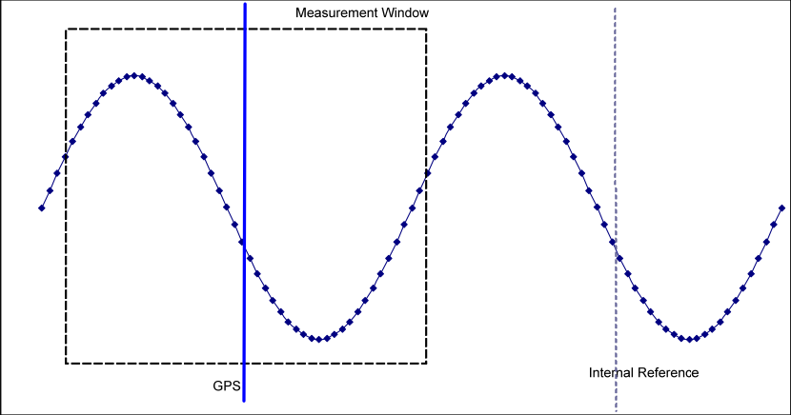

Fig.5.Phasor window [9]

The Phasor once calculated are encapsulated into data frames for transmission across an Ethernet network. The MiCOM P847 functions like an Intelligent Electronic Device (IED).It has capability to send and receive Generic Object Oriented Substation Event (GOOSE). It has 8 relay contacts and 16 opto isolated inputs which could be configured to design a particular logic scheme using the inbuilt Programmable Scheme Logic (PSL) environment of MiCOM P847.So the PMu can be configured not only to calculate Phasor but also perform control actions thus helping in automation of the substation where it is installed [9].

* 1. Hardware Interface for Analog Signal Acquisition

The hardware interface provides an adaptation of the signal from the analog outputs of the RTDS to the input signal range of the PMUs in order to enable the Synchrophasor measurement using the commercial PMUs. The RTDS output signals are amplified to mimic the secondary side of current and voltage transformers. The MiCOM PMU has a rated input voltage limit of maximum 100/√3 to 120/√3 and currents of either 1A or 5A. However, it was also found from various tests that minimum signal strength of at least 38 % of the rated quantities were required for the Phasor to be published.

* + 1. Structure

The grids are simulated in RTDS and the analog signals corresponding to the three phase voltage and current of different buses and branches respectively can be obtained through the GTAO ports of the RTDS. The signals at the simulation level are scaled to 10 V and are routed through the GTAO ports. Then the signals are fed into a signal conditioner which conditions the signal to meet the requirements of the following stage ,which in our case is the voltage and current converter (ALTEA Electronic converter) which emulates the secondary side of the potential and current transformer. The Fig.6 depicts the simplified diagram of the hardware interface between the RTDS and PMU. The **错误! 未找到引用源。** depicts the real hardware used for the interface



Fig.6.Overview of hardware interface between RTDS & PMU

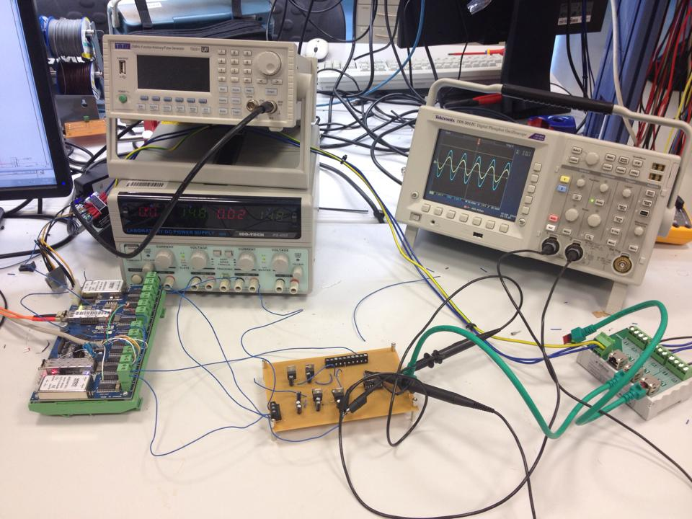

**GTAO**

**ALTEA**

**Amplifier**

**Signal Conditioner**

Fig.7.Hardware interface

* + 1. Signal Conditioner

Signal conditioning means adapting an [analog signal](http://en.wikipedia.org/wiki/Analog_signal) in such a way that it meets the requirements of the next stage for further processing. The output ports of RTDS act as the transducers, the signal conditioner conditions the signals of the transducers so that it meets the requirement of the Altea converter which then amplifies the simulation level signals into a real power system level. RTDS gives an output signal ranging ±10 V whereas the input range of ALTEA converter is ±1 V. Altea converters are electronic voltage and current amplifiers designed by Altea power monitoring solutions. It amplifies voltage signals of 1V to 100/√3 V and current signals of 1V to 1 A .The basic functional part of the signal conditioner is the Op-amp .

The basic characteristics of an Op-amp can be described as a device that amplifies a differential input voltage with very high gain and presents it at the output. Ideally the Op-amp is assumed to have infinite gain, infinite input impedance, infinite bandwidth and zero output impedance. This means that it doesn’t draw current from the input and when multiple operational amplifier are connected in cascade then proper signal isolation could be achieved. It also means that signals of any frequency could be amplified the same way. But in practice op-amps have a finite bandwidth and gain, given by the gain bandwidth product (GBP). In open loop conditions the operational amplifiers have very high gain in the order of 106 with a very low corner frequency or bandwidth. However in closed loop conditions (inverting and non-inverting mode of operation) the bandwidth could be increased at the expense of the gain.

As according to an experimental test [11]it was experimentally proven that the open loop transfer function of an operational amplifier resembles that of a first order low pass filter and is given as in Eqn.4 [11].

|  |  |
| --- | --- |
|  |  |

The GBP is given as in equation (Eqn.5) [11]

|  |  |
| --- | --- |
|  |  |

From the specifications of the output port of RTDS and the input range of the ALTEA amplifier it is clear that the output signal from RTDS has to be scaled down from 10 V to 1 V. For such an application the operational amplifier should be operated in inverting mode.

In the inverting mode of the operational amplifier the input signal could be scaled down but in the process the signal would suffer a phase shift of 180 degrees. The scaling of the gain is achieved by properly selecting the feedback resistor Rf and the input resistor Rin. In the classical feedback theory the inverting operation mode of the operational amplifier could be represented like in the Fig. 8 given. Where P(s) is the relationship between the input signal and the inverting terminal voltage of the operational amplifier, H(s) the plant transfer function in this case the open loop transfer function of the operational amplifier as defined in Eqn.7 and F(s) defines the feedback properties. The transfer function of an operational amplifier operated in inverting mode can then be simplified as in equation



Fig. 8.Classical feedback model of Op-Amp [11]

|  |  |
| --- | --- |
|  |  |

From the equations (Eqn.6 to Eqn.7) it can be derived that in an inverting configuration of the operational amplifier the P(s) and F(s) [11]

|  |  |
| --- | --- |
|  |  |
|  |  |

Substituting Eqn.8 and Eqn.9 in Eqn.7 would give the overall transfer function given in the Eqn.10 [11].

|  |  |
| --- | --- |
|  |  |

From the equations it can be deduced that for a signal to be scaled down the operational amplifier needs to be configured for inverting mode of operation. From the transfer function derived it is clear that input signal will suffer a shift of 180 degrees. Therefore to nullify this effect another operational amplifier has to be connected in cascade and configured to operate in inverting mode .Thus the signal conditioner is designed with a two staged amplification. The first stage to scale it down and the second one to nullify the inversion introduced by first stage and to amplify the signal appropriately to match the input requirement of the ALTEA voltage and current amplifier.

Apart from matching the input requirements of the ALTEA converter, the signal conditioner is also designed to have an inbuilt protection functionality to limit the over voltages at the output. The design of the signal conditioner is as given in the Fig. 9.



Fig. 9.Circuit diagram of signal conditioner

To realize such a protection feature clamping diodes are used at the output of the first operational amplifier such that the voltages are appropriately clamped and the pre-clamped voltages are applied at the input of the cascaded operational amplifier. The diodes clamp the output voltage at their forward biasing voltage. General purpose diodes are selected for this case and they have a forward biased voltage around 0.7V.Therefore the Rf1 and $Rin1$ Rin1 are selected in such a way that a 10 V input is scaled down to 0.7 V and Rf2 and Rin2 such that 0.7 V at the input of the second operational amplifier is scaled to 1 V, thus matching the input voltage requirements of ALTEA converter. Instead of general purpose diodes zener diodes would be the ideal choice for clamping .The zener diodes clamp the voltage to their reverse blocking voltage. Subsequently appropriate values of the feedback and input resistances of both the operational amplifiers have to be chosen to achieve the required scaling. A list of possible values has been tabulated in table (Table.1).

Table.1.Specification for the scaling resistors

|  |  |  |  |  |  |
| --- | --- | --- | --- | --- | --- |
| **Clamping with** | **Clamping Voltage** | **Rin1 (kΩ)** | **Rf1 (kΩ)** | **Rin2 (kΩ)** | **Rf2 (kΩ)** |
| General Diode | 0.7 V | 2 | 1.47 | 1 | 1.47 |
| Zener Diode | 2 V | 10 | 5 | 2 | 1 |

To analyze the performance of the signal conditioner the equivalent transfer function of it is derived by using Eqn.9 and is given as Eqn.10 [11].

|  |  |
| --- | --- |
|  |  |

The bode response of the signal conditioner is plotted in Fig.10. It can be inferred from the plot that the signal conditioner doesn’t introduce any phase shift to the input signal in the power system frequency level and introduces a scaling of 0.1 for a very large bandwidth. From the bode plot it is clear that at 50 Hz the signal is scaled by a decade and with no phase shift introduced.



Fig.10.Bode plot of signal conditioner

* 1. NIcRIO PMU for Dynamic phasors

The NIcRIO PMU is a prototype of a PMU built with hardware of National Instruments (NI). It is capable of calculating dynamic phasors as per the synchrophasors standard [4].The signal acquisition board of NIcRIO is capable of sampling 3 channels of signals at 10k Hz simultaneously. The time tagging is done by the GPS unit which is on board. The GPS unit synchronises the FPGA which in turn tags the samples of the signal acquired by the signal acquisition board. The input range of NIcRIO is ±10 V therefore the analog signals from RTDS can directly be sent via GTAO card.The NIcRIO is compatible with only 50 Hz signals. It can report phasors at 50 fps (frames per second). The dynamic phasors are calculated using non DFT methods based on Kalman filter techniques.

* 1. Scaling of Phasor Measurements

With the commercial MiCOM P847 PMU the scaling of the signals received can be manually applied such that the phasors correspond to the voltage or current values as simulated in RTDS. But if the same PMU is to be used for different projects then one has to change the scaling settings every time. Therefore it is recommended that the scaling factor of the commercial PMU be set to 1 and the appropriate scaling be applied to the pahsors at the application end. For example in the Online DSSE application the scaling of the phasor measurements is applied in the Measurement \_Aggregator function. The scaling factor for a generic phasor published by MiCOM P847 PMU can be given as in Eqn.11.

|  |  |
| --- | --- |
|  |  |

For the phasor measurements from NIcRIO the scalling factor can be given as Eqn.12.

|  |  |
| --- | --- |
|  |  |

Where KSim is the RMS value of the simulation signal that corresponds to 10 V output of the GTAO.

* 1. Synchrophasor Data Processing and Management – OpenPDC

The open source Phasor data concentrator (OpenPDC) is an evolution of the SuperPDC originally developed at the Tennessee Valley Authority (TVA). It is a system that is used to manage, process and respond to dynamic changes in fast moving streaming Phasor data. More specifically, the openPDC can process any kind of data that can be described as "time-stamped measured values" [12]. When a value gets measured, along with its timestamp, is then streamed to the openPDC where it can be "time-aligned" with other incoming measurements so that an action can then be taken on a complete slice of data that was all measured at the exact same moment in time. The system processes any type of time-series measurement data in a protocol independent fashion. This is possible due to the system’s extensible modular design as described in coming sections.OpenPDC is a conglomeration of different projects namely TVA.Historian , TVA.PhasorProtocol and the Time Series Framework. The modular structure of OpenPDC is provided by the different adapters which are actually extensions of the classes defined in the aforementioned projects [12]. Therefore extension to these adapters and introduction of new classes with different functionalities can be done and easily added to the source code of OpenPDC which makes it possible for developing standalone and complex measurement acquisition system. The basic build of OpenPDC is already capable of handling Synchrophasors from multiple PMUs and no special classes or functions need to be defined for acquiring Synchrophasor. It acts as a software interface for the PMUs which aggregates the Synchrophasor measurements and makes it available for further processing. It is a critical connection block in designing an online monitoring system. The installation and configuration procedures for OpenPDC are described in the Appendix 9.3-9.5.

* + 1. OpenPDC Architecture

OpenPDC is architecturally split into three layers, the input, action and output layers, each with its speciﬁc set of functionalities. The input, action and output layers deal with measurement acquisition, measurement processing and measurement routing and forwarding tasks respectively as depicted in the Fig.12 [12].

The input adapter layer facilitates the development of input adapters that support different protocols. The input adapter is configured in such a way that it accepts the measurements from a particular device strips down measurements and makes it available for the action or the output adapter layers for further processing. At present the input adapters layer supports IEEE C.37.118 , IEEE 1344, BPA PDC Stream, IEC 61850 -90-5 ,UTK F-Net. Custom input adapters can also be developed that support other protocols so that other systems could also be interfaced [13].

The action adapter facilitates the processing of the measurements provided by the input adapter. The measurements received by the action adapter are already stripped down by the input adapter. Therefore direct mathematical operations can be directly done on it. Furthermore special actions like calculating power from the voltage and current phasors can be done with the help of custom action adapter. The calculated measurements can then be sent to the output adapter which then saves it into a file or a database. Furthermore it also supports functionalities like the real-time event detection tasks. It processes the incoming measurements and checks if they fall within the acceptable range of pre-set parameters like over or under voltage and current limits, failing which, the event task informs subscribers of such occurrences. The frequency excursion detection is such an example of an event detection task that is bundled with openPDC [13].

The output adapter layer is responsible for routing the measurement data as required by the subscriber/application. Output adapters can be configured in this layer that can save the data into a .csv file using the Comma Separated Values (CSV) output adapters, store the data into a database using ADO or MySQL adapters , encapsulate the data into several other protocols like the concentrated output stream or the Inter Control Centre Protocol (ICCP) and sent to remote control centers for further processing . The steps to set up input and output adapters are explained in the Appendix 9.3-9.5 . The default functions of the three layers are given in the Fig.11 [13].The input adapter layer maps the phasor measurements received to the device which generates it and parses the stripped measurement data to the subsequent layers. The action adapter sorts the received data according to the time and processes them to see if there are any time quality errors. It also creates secondary measurements like power from the voltage and current phasors and passes on to the output layer. The output layer processes the measurements sent by the action layer queues them to be stored into databases and creates CSV files into which the data can be stored.



Fig.11.Default functions



Fig.12.OpenPDC architecture

* + 1. OpenPDC Configuration for Online Monitoring Systems



Fig.13.OpenPDC configuration for online monitoring applications

The Fig.13 depicts the structure in which the different layers of OpenPDC should be configured for online monitoring applications. This configuration is the basic configuration required for any kind of monitoring applications. For advanced applications which require derived or secondary measurements action adapters can also be configured.

The basic action adapters required for the acquisition of synchrophasors are the alarm service adapter, statistic service adapter and the external publisher adapter that sorts the incoming synchrophasors according to the time. These action adapters are inbuilt in openPDC and are automatically configured while setting up OpenPDC.

The input adapters are extensions of the InputAdapterBase defined in the Time Series Framework project. The InputAdapterBase is a class defined in the project. All the functions of the InputAdaterbase are defined in that class. Similar is the case of OutputAdapterBase. Configuration of each input adapter requires two files namely the PMU Connection file (.PMUConnection) and PMU configuration file (.xml). These two files are unique for every PMU. The former has the information about the IP and port addresses of the PMU to which the input adapter of the openPDC has to listen to, to obtain the Phasor. The later provides information on how to read the measurement data received by the input adapter or in other words the synchrophasor protocol used by that particular PMU. The input adapter strips down the measurement and retrieves the data and makes it available for the subsequent layers.

Unlike to the input adapter the output adapter is an extension of the OutputAdapterBase defined in Time Series Framework project. Using the appropriate output adapters, measurement data can be either stored into a .csv file or saved into a database or can be queued to be sent to remote clients depending on the demands of the application that subscribes the data . The individual measurements saved or queued could be identified by a unique measurement key which has a format “Output\_Adapter\_Name : number ” . For example the Fig.14 shows some of the individual measurements and the statistics associated with the synchrophasors sent by a MiCOM: P847 Alstom PMU. From this figure it can be seen that each measurement has its own ‘ID’ which has the aforementioned format. So the ‘ID’ can be used to identify the measurement. This identification key is very critical for applications as they can be programmed to identify automatically a particular measurement using this identification key.

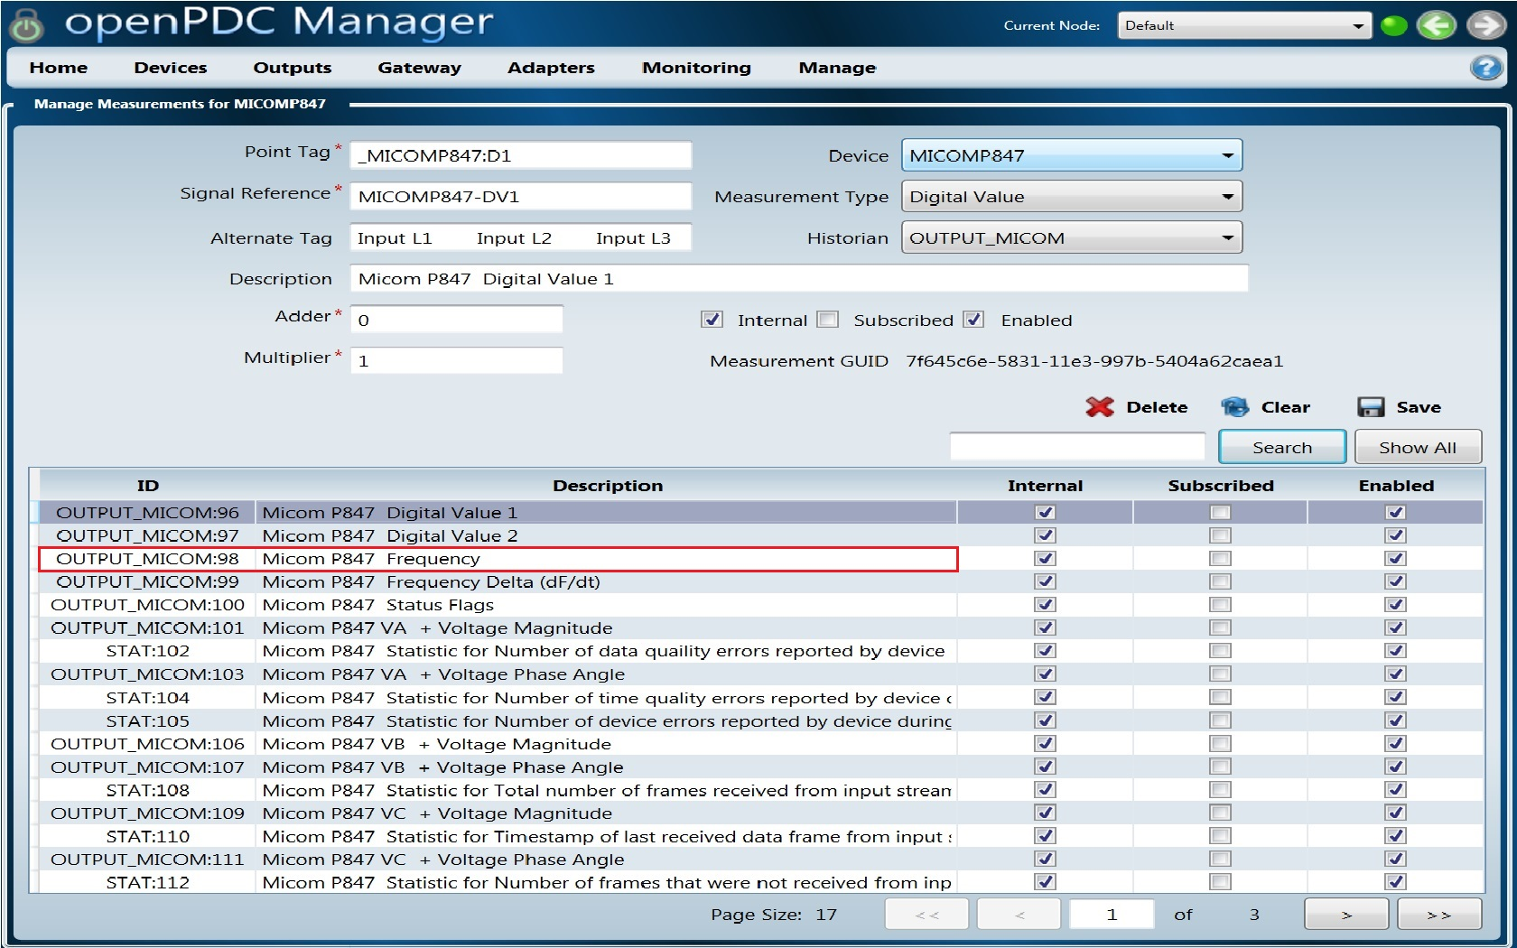

Fig.14.List of measurements shown in OpenPDC

OpenPDC is designed to work as a Phasor Data Concentrator. The main function of the PDC is to collect the phasor measurements from different PMUs and club them in one stream according to the time tag of the measurements and send it to a SuperPDC or to a control center with different reporting rates. Such functionality could also be realized in OpenPDC through configuring Concentrate Output Streams component in OpenPDC. This component allows the user to select the measurements from multiple devices that need to be sent to a remote location. It also gives the user an option to determine a new reporting rate than the one with which the phasors were reported by the PMU to this PDC.

* 1. Summary

In this section the complete proces of obtaining the phasors from the analog outputs of RTDS is presented. The working principle of the generic PMU , commercial PMU of Alstom and that of the PMU prototype NIcRIO are presented. The software interface that acts as the PDC which processes and manages the phasor data and makes it available for the applications is OpenPDC. A detailed explanation of the architecture and configuration required for the online monitoring systems is explained.

1. Software platform for Control Centre

This chapter describes a general structure of the software platform required for supporting advanced monitoring and control applications of the control center. The primary requirements of the control center applications are the measurements from different devices which might be sent in different formats. Therefore a software platform is required that can acquire these measurements and is able to extract the measurement data from it and facilitate this extracted data to the applications .This chapter describes the principle layers of the software platform and the interactions between them. The platform is designed to facilitate the measurements received to the applications through database. A detailed explanation of the configuration of the database for facilitating synchrophasors data is presented. . A general overview of the platform developed and the possibilities of its further extension are described in the first section .In the subsequent sections a detailed explanation of the interaction between the different layers is presented focusing the integration of phasor measurement for state estimation application. Though this chapter describes the software platform focusing on the integration of synchrophasors measurements for state estimation application, the platform is general and is applicable for any kind of measurement data for any kind of application.

* 1. Overview



Fig.15. Software platform for control center

The software platform for control center is designed to manage the measurements received from different sources in different formats and facilitate them to the applications through a common data storage option. The software platform is principally divided into three layers namely the measurement interfacing layer , the measurement storage layer and the application layer as shown in Fig.15.The first part, denoted as measurement interfacing layer is responsible to read measurements of different formats, extract the measurement data and present raw measurement data without the formatting to the next layer in the architecture. OpenPDC is used as the software for synchrophasors and OPC server for measurements in DNP3 format.

Once the measurement data from different devices with different formats have been extracted, the next layer, Measurement storage layer stores all the measurement data in a common format such that different applications irrespective of the environment in which they are developed could access. For the common storage options database (MySQL, SQL etc..), in text files or CSV files can be used.

The next level and the highest section in the structure of the monitoring platform is the application layer. All the higher level applications for e.g Online State Estimation, control applications or visualization applications could be developed in different software environments/tools such as MATLAB or Labview.

. The main connection link between the application layer and the measurement interfacing layer is the measurement storage layer which is predominantly the database. For the monitoring platform MySQL database is used. This chapter describes the configuration of database that is necessary to support both the measurement interfacing layer and the applications in the application layer.

The proposed software platform can be extended to incorporate the Supervisory Control And Data Acquisition (SCADA) system as shown in Fig.16.The phasor measurements will be managed by OpenPDC the classical measurements by OPC and the comlete acquired measurements will be managed by SCADA.



Fig.16.Extension of software platform with SCADA

* 1. Measurement Storage Layer – MySQL Database

The measurements extracted by the measurement interfacing layer can be stored as text files or as CSV files. However, with databases large data storage and advanced data processing functions could be enabled for easy access by higher level applications.

Databases are created to operate large quantities of information by inputting, storing, retrieving, and managing that information. With respect to the power system monitoring systems where measurement data comes from varied sources, a database plays a crucial role in providing a common storage and processing instant that provides data access to multiple applications. The synchrophasors, classical measurements, pseudo measurements and other miscellaneous data could be stored and made available to multiple applications for further analysis. Unlike the pseudo measurements, which generally are historical data, the other measurements are received by the control center in different formats for which specialized software or programs are required to decode and extract just the required information. For e.g. OpenPDC extracts measurement information out from the data sent in Synchrophasors format and through Ado adapters saves into database. Similarly, an OPC server extracts measurement information from data sent in DNP 3 format and stores into database. The data stored in the databases are generally stored in a table format. Each table has multiple columns, and every measurement data with associated attributes is stored as a row in the table. When a streaming data like that of the synchrophasors are stored into the database with the help of OpenPDC, every new measurement is stored in a new row in the order of arrival. It means that the measurements are stored chronologically according to their time stamp.

Tables are the functional unit of a database. Configuring a database is to set up the different tables in it into which the data is stored. Irrespective of the source of the data once stored in database the measurement data is available in the same format. Therefore it becomes important to properly create tables. Separate tables should be created for measurements from different sources. So that measurements from a particular device can always be found in a particular table. By doing so it becomes easy for the applications to search for the required measurements from the database.

By using database as the channel to deliver measurement data to the application have the following benefits:

* The applications irrespective of the environment/tools they are developed in can get access to the measurement data irrespective of the format in which they were sent by the devices.
* Data archiving is achieved.
* Data is stored chronologically

In the proposed platform, the synchrophasors measurements are received by OpenPDC and stored into the database through the Ado Adapters into separate tables, such that each table stores measurements of a particular PMU. As a future work Classical measurements sent in DNP 3 format would be saved into different tables of the database via OPC, such that measurements in each table correspond to the measurements sent by the particular traditional device. The Fig.17 shows a snapshot of the synchrophasors measurements of a PMU in database. The table has four column names which are the “Reference\_id” corresponds to the index number, the “MeasurementKey” which is the measurement identification code ,under “Value” the value of the measurement is stored and under “TimeStamp” the time stamp of the measurement is stored and the “StateFlags” show the status of the measurement if there is no error when it was received.The value is generally 0 if there was no error..

A detailed explanation of how to configure the database and its tables is given in the Appendix 9.6 and 9.7.

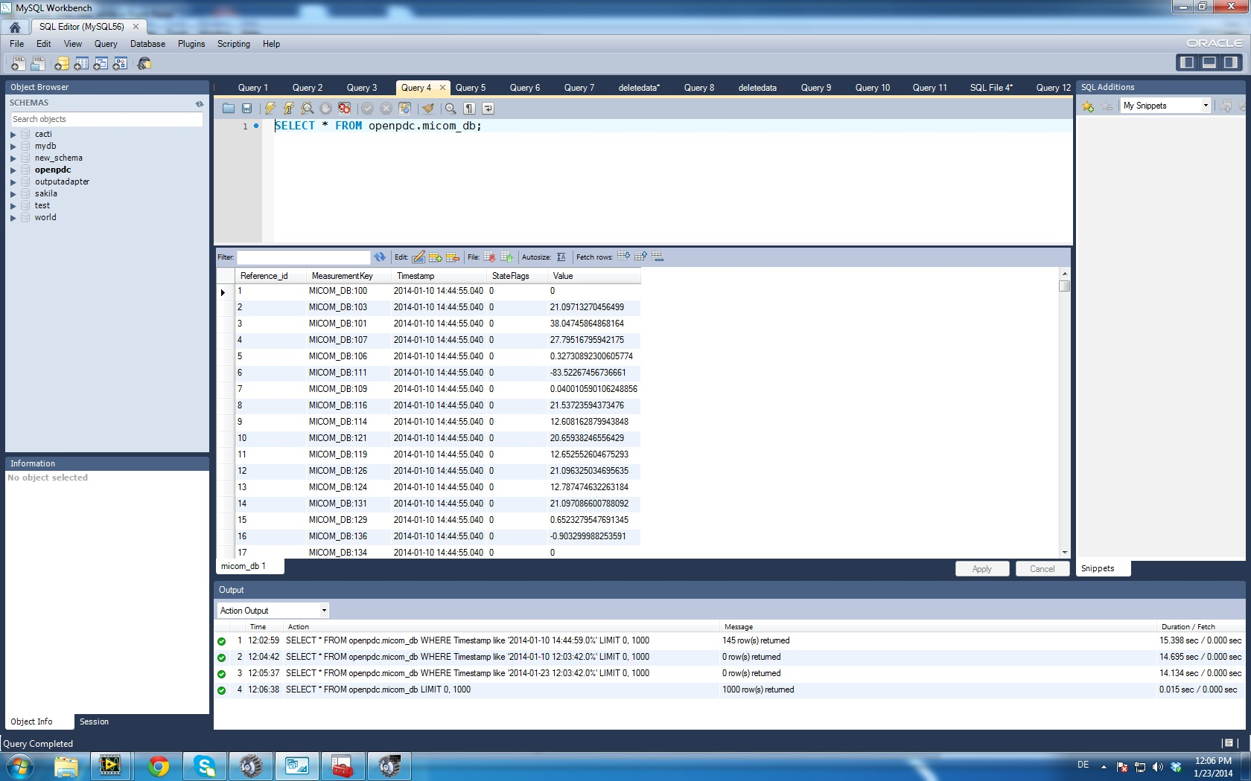

Fig.17.View of a table in a database

* 1. Interactions between Storage Layer and Measurement Interfacing Layer
     1. Configuration of Database for OpenPDC

The Ado Output Adapters of OpenPDC are responsible for saving the measurement data into the databases. OpenPDC is configured in such a way that each input device in the physical world will have a corresponding Ado adapter configured. As shown in Fig.18 the PMU measurements from each PMU are saved in separate tables and preferably in different database instances. Each Output adapter is configured to store the Phasor measurements in different tables.



Fig.18.Database configuration for OpenPDC

Storing the PMU measurements from different devices into different tables which are in different database instances would be the most proper solution. This is because of the limitations of the Ado adapters of OpenPDC. Each ADO adapter has a limit in handling streaming data. Considering the fact that the MiCOM Alstom PMU is able to send 30 measurement every 20ms and if all the four PMUs are connected to the same OpenPDC and all measurements from them are stored into the database then the database has to update 6000 rows of data in one second. Practical limits of an ADO adapter is around 1700 measurements per second as given in [14].But this limit can be increased to 2048 or to 4096 by setting up the buffer limit in the connection string of the particular ADO Adapter. As discussed in [14] it is also clear that the performance is compromised at higher buffer limits. Moreover, the online applications would be trying to retrieve rows of data while the table is being updated by new measurements from OpenPDC. In such conditions there would be multiple SQL queries running on the same table simultaneously, which might cause the instabilities and may cause the database to crash. Therefore only a limited number of measurements need to be stored in every database. This can be achieved by creating different database instances in different PCs and assigning a limited number of PMUs to every PC.

As a proposal shown in Fig.19 every PC serving as a PDC collects data from 2-3 PMUs and storing them into the database. The applications that require Phasor measurement data just from 2 PMUs could be either run in PC1 or PC2 .But if an application requires data from all the PMUs then the application could be run on a third PC which receives data from the other two PCs (PC1 & PC2) through the concentrated output stream adapter of the OpenPDC configured in both the PCs (PC1 & PC2).



Fig.19.Proposed Structure for the Phasor Measurement System

By storing measurement data in different tables in different database instances, the updating rate per table would be less and could be handled by the normal data handling functions defined in the database. The Fig.18 shows the general configuration of the database that receives data from the Ado adapters of the OpenPDC. From the figure it is clear that measurements from each Ado Adapter are stored in a separate table. Each table is characterized by the columns. The figure shows that the tables are defined in the MySQL database named “openpdc”. A basic table with columns as the Index, Meas Key, Value (value of the measurement) and the Time Stamp respectively from left to right is depicted. The index just gives the row number. Meas Key is the unique Measurement Key assigned to every measurement that can be used for identification. The value of the measurement would be stored under the Value column and the corresponding time stamp of the measurement would be stored under the Time Stamp column. Appendix 9.6 & 9.7 describes the detailed procedures of setting up the database and the tables in the database for the Phasor measurements.

* 1. Interactions between Storage Layer and Application Layer
     1. Application Layer and its Interactions with Database

An overview of the connections between the database and the applications is depicted in Fig.20. For every application as depicted in the figure a measurement aggregator is defined to collect the measurement data from different sources. The functionalities of the measurement aggregator depends upon the data required by each application.



Fig.20.Application layer and its interaction with MySQL database

The different applications run at the control center constitute the application layer. Each application as shown in Fig.20 is built to have a child function called Measurement Aggregator. It interfaces the application with the measurement storage layer. The application is the parent function and the measurement aggregator the child function. It is the duty of the measurement aggregator to retrieve measurement data from the storage layer and build the measurement vectors as required by the application. The measurement aggregator should be designed in the same environment in which the application is designed. This eases the parsing of the data to the application. The measurement aggregator should have dedicated sub functions that retrieve data from different data storage options. For e.g as shown in Fig.20the measurement aggregator of Application 1 has three different sub functions namely the Database\_reader\_1, Text\_reader\_1 and CSV\_reader\_1. These three sub functions search the measurement data required by the application in the database, loads the appropriate text files and CSV files respectively. Once the different measurements are aggregated by the Measurement Aggregator it builds the vector of these measurements as required by the application and parses these vectors to the application when the application calls for it.

* 1. Remote Phasor Measurement Acquisition

The PMUs are generally installed in substations and in most applications the phasor data is used at locations remote from the PMUs [5].A generally accepted hierarchical architecture of phasor measurement systems is as given in the Fig.21.General Heirarchy in Phasor Measurement Systems.It is the Phasor Data Concentrator (PDC) that gathers data from several PMUs , reject the bad data , align the time-stamps and create a coherent record of simultaneously recorded data from a wider part of the power system [5].



Fig.21.General Heirarchy in Phasor Measurement Systems

Considering the situation where the PDCs and Super PDCs are geographically separated, which is generally the case is, the quality of the communication channel between the PMUs and PDC and between PDCs and Super PDC will determine the performance of the phasor measurement system. The phasor data passes through different networks before it either reaches the PDC or SuperPDC. In practice the communication channel introduces latency, jitters and data packets loss. With respect to the monitoring platform developed the hierarchical phasor measurement system can be implemented as given in [5]. Both PDC1 and PDC2 use OpenPDC to stream the phasor measurements received by them into a stream and send it to the Super PDC by using the Concentrate Output Stream utility of OpenPDC software. The Super PDC also uses openPDC to receive the data stream from the other two PDCs. The communication is through ethernet using TCP/IP protocol. A virtual network is setup between the PDC and SuperPDC that acts like a real network which introduces latency, jitters and packet loss. The virtual network is simulated through WANEM emulator.By simulating such a scenario with virtual network the robustness of OpenPDC to send and receive streaming data through different networks can be tested. In this section a preliminary test, with a stream of phasor measurements, is sent from the PDC to SuperPDC through the virtual network setup by WANem emulator. The phasor measurements correspond to just a PMU.



Fig.22.Phasor Measurement Heirarchy with WANem network

* + 1. WANem

WANem is a Wide Area Network Emulator, meant to provide a real experience of a Wide Area Network/Internet, during application development / testing over a LAN environment. Typically application developers develop applications on a LAN while the intended purpose for the same could be, clients accessing the same over the WAN or even the Internet [15]. Network emulation is a technique where the properties of an existing, planned and/or non-ideal [network](http://en.wikipedia.org/wiki/Telecommunications_network) are simulated in order to assess performance, predict the impact of change, or otherwise optimize technology decision-making. Network [emulation](http://en.wikipedia.org/wiki/Emulator) is the act of introducing a device to a test network (typically in a lab environment) that alters packet flow in such a way as to mimic the behavior of a production, or live, network — such as a LAN or WAN. This device may be either a general-purpose computer running [software](http://en.wikipedia.org/wiki/Computer_software) to perform the network emulation or a [dedicated emulation device](http://en.wikipedia.org/wiki/Emulator). Devices incorporate a varying amount of standard network attributes into their designs including: the round-trip time across the network ([latency](http://en.wikipedia.org/wiki/Lag)), the amount of available [bandwidth](http://en.wikipedia.org/wiki/Bandwidth_(computing)), a given degree of [packet loss](http://en.wikipedia.org/wiki/Packet_loss), duplication of packets, reordering packets, corruption and modification of packets, and/or the severity of network [jitter](http://en.wikipedia.org/wiki/Jitter). Higher-end network emulators can also mimic typical Layer 1 physical errors such as Bit Error Rate, Loss of Signal, Output Bit Rotation, and others.

It is commonly known that networks are imperfect — private or public. They introduce delay and errors. They go down. They drop packets. The primary goal of network emulation is to create an environment whereby users can run OpenPDC and evaluate its performance, stability, or functionality against real-world network scenarios. Once tested in a controlled environment against actual network conditions, users can have confidence that OpenPDC will perform as expected.

* + 1. Test Case

The test case as in Fig.22 was simulated. The stream statistics of OpenPDC at the PDC side and the stream statistics of the incoming stream at the SuperPDC side are shown. The OpenPDC is robust and performs well. By tuning the *lag* and *lead time* parameters of the Concentrated output stream utiltity the performance of OpenPDC could be improved. The stream statistics are shown in Fig.23 . The expected phasors to be received is as shown are 13504 but due to the packet loss introduced by WANem only 10800 phasors were received as WANem introduced around 17 %. 14 synchrophasor had to be realigned as they were received at different times due to the jitter introduced by WANem.

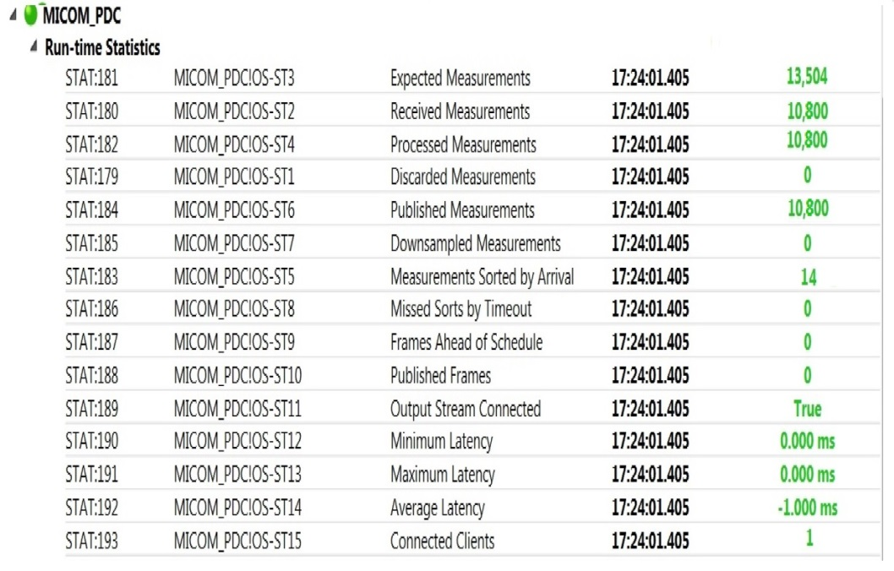

Fig.23.Stream statistics with WANem

* 1. Summary

This chapter describes the general software architecture for control center applications. The suggested architecture is highly helpful for the application developer as the applications can be developed in varied environments irrespective of the format in which the real measurements from the devices are received. A one to one connection between different measurement interfacing softwares and the applications can be tedious and in some cases impossible. Therefore a common platform where data from multiple measurement interfacing softwares could be stored would be a great advantage . For that purpose database is an ideal choice as most of the application development environments support databases and also the measurement interfacing softwares. The importance of the measurement aggregator in the application design is presented. The interaction of the different layers of the software platform for advanced monitoring and control applications is described. A real worl scenario where the different PDCs have to communicate with the SuperPDC is simulted . A network emulator WANem is used to simulate a virtual network through which the PDC would communicate with the SuperPDC. Performance of OpenPDC in such real world scenario is tested and was found to be robust even with a considerable jitter and packet loss.

1. Application - Online Distribution System State Estimation

In this thesis the Distribution System State Estimation (DSSE) is developed as an online application to showcase the developed real-time simulation platform. State estimation is the fundamental mathematical tool through which the system awareness can be obtained. For designing the advance control and operation strategies, the awareness of the system state is very critical and therefore in the monitoring platform developed, the application of online state estimation is incorporated. In this chapter a detailed explanation of the design of the online DSSE is presented.

* 1. Overview

In a nutshell Fig.24 depicts the various inputs required for the DSSE to function. Apart from the measurements which would be described later in this section it also requires the network data and the accuracy weights corresponding to the kind of measurement. Pseudo measurements would be having the least accuracy weights and the PMU measurements would be having the highest accuracy weights.



Fig.24.Inputs and outputs of DSSE

The DSSE applied in this thesis is a two-stage estimation algorithm [16]. In the first step an initial estimate, of the sates, is calculated with the traditional measurements and in the second step PMU measurements are included and a post processing of the initial states is done. Fig.25shows the kinds of measurements included in the DSSE.



Fig.25.Measurements for DSSE

For an online state estimation application all the measurements should be available in real time. Therefore RTDS is used to simulate the grid and obtain the measurements. In this thesis a 16 bus radial distribution grid is simulated. The classical measurements are obtained from RTDS.

The buses where PMU is placed are randomly chosen to be at Bus 4, Bus 10 and at Bus 16. The state estimation is done considering only 1 PMU measurements at a time. RTDS through its GTAO output card generates output signal corresponding to the voltage magnitude and phase angle at those buses. This signal after proper amplification is fed into the PMU to obtain the corresponding Phasor.

Pseudo measurements at every bus are obtained as the historical data stored in an excel file. Through script file the load demand at different buses could be changed and for every change in the loading pattern the real and smart meter measurements are captured and stored into a text file.

Throughout the simulation the bus voltage signal at bus 4, 10 and 16 are made available to the PMUs for generating the synchrophasors. The changes to the loading conditions are applied every minute. The online DSSE is designed with a timer object such that it estimates the states with the traditional measurements from the text file and the PMU measurements from the database after every change in loading condition simulated in RTDS. The measurement aggregator has different functions defined like that to read the text file, read the excel file and the database and provide the DSSE with the required measurement data as vectors Fig.26 describes the complete process.



Fig.26.Measurement acquisition process for DSSE application

The following sections describe the design and working principle of online DSSE application and show a test case simulated with a 16 bus UK radial distribution grid.

* 1. Acquisition of classical measurements through scripts

The classical measurements can be obtained from RTDS in real time in different methods. One is through GTNET in DNP 3 and SV format. The other method is through scripts where the real time measurements are stored in text files. Or through GTAO where the measurements can be sent as analog signals to external devices. But for this thesis scripts are used to provide classical measurements for the application. The flow chart of the script file is given in Fig.27. In the first the variables are initialized. The run file of the RSCAD is started. Then for each loading condition the real traditional measurements are captured through meter components of the run file of RSCAD and saved those captured values into arrays in a text file. This text file is stored in an external hard disk to which the application has access. For every new loading condition a new text file is generated which replaces the old one when stored in the external hard disk.



Fig.27.Script file for online DSSE application

* 1. Two step DSSE

From measurements corrupted with noise and errors the system states can be derived by using mathematical tools like state estimation. DSSE is two staged state estimation process that uses Weighted Least Square (WLS) method to estimate the states, in the first step using the traditional measurements and then implement a post processing process on the system states using the PMU measurements [16]. Via iterative WLS method the DSSE estimates the initial states by minimizing the cost function J as given in Eqn.14. The superscript (1) or (2) indicates the first or the second step of the estimation [16].

|  |  |
| --- | --- |
| J=(z1-h(x(1)))T (W1)-1 (z1-h(x(1))) |  |

Where z1 is the vector of traditional measurements, x(1) is the vector of state variables (voltage magnitude and phase angle)estimated in the first step, W1 represents the covariance matrix of the traditional measurements which incorporates the covariance matrices of real measurements, smart meter measurements and pseudo measurements. h(x(1)) denotes the nonlinear relationship between the state variables and the measured variables .

The relation between the vector of measurements and nonlinear measurement function in terms of the state variables can be given as Eqn.15 [16].

|  |  |
| --- | --- |
| z1=h(x(1))+ε1 |  |

Where ε1 is the measurement error with zero mean and a covariance W1. The state vector x(1) is estimated iteratively via WLS method according to the Eqn.16 [16].

|  |  |
| --- | --- |
| xk+1(1) = xk(1)+G1(xk(1))-1(H1T(xk(1))W1-1)(z1-h1(xk(1))) |  |

where xk(1) is the estimated state in the first step during the kth iteration of x(1). H1 denotes the Jacobian matrix obtained by taking the partial derivative of measurement function h(x)with respect to xk(1) . W1-1 is a diagonal matrix of covariance matrices of real measurements, smart meter and pseudo measurements given as Eqn.17 [16].

|  |  |
| --- | --- |
| W1-1=diag((W1,real)-1, (W1,smart)-1, (W1,pseudo)-1) |  |

G1(xk(1)) is the gain matrix given as Eqn.18.

|  |  |
| --- | --- |
| G1(xk(1))= (H1T(xk(1))W1-1 H1(xk(1)))-1 |  |

Basically the gain matrix at every iteration gives the inverse of the estimation error of the state vector estimated in the kth iteration. Therefore as the gain matrix approaches infinity the estimated states approach the true values. The covariance matrix of first step estimation error is given as Eqn.19 [16].

|  |  |
| --- | --- |
| Wx(1)= H1T(x(1))W1-1 H1(x(1)) |  |

This covariance matrix is used in generating the covariance matrix of the post processing step. Because the first step estimates are considered as measurements for the post processing step.

After the first estimate of the state vector is made, the PMU measurements are included for post processing and the state vectors are updated. In this thesis only voltage phasors are included. In order to simplify the updation of the state vectors a linear estimator is used for which the state vectors and the PMU measurements are represented in rectangular format.

The new measurement vector is composed of the first step estimation of the states and the PMU measurements as depicted in equation Eqn.20 [16].

|  |  |
| --- | --- |
| z2==+ ε2 🡪A xrect(2)+ ε2 |  |

where *I* is an identity matrix and *I\** is a sub matrix of an unity matrix where the rows corresponding to those buses where PMU is not placed are dropped. ε2 represents the estimation error associated with the post processing. The estimation error is considered to be having zero mean with W2 as the covariance matrix. The updated state estimates could be calculated linearly according to the Eqn.21 [16].

|  |  |
| --- | --- |
| xrect(2)=[AT(W2)-1A]-1[AT(W2)]z2 |  |

where W2 is given as equation (Eqn.23).

|  |  |
| --- | --- |
| W2=diag(Wx(1)rect,WPMUrect) |  |

where WPMU isthe covariance matrix of the PMU measurements. Generally both the covariance matrices Wx(1),WPMU are defined for polar quantities. But since post processing requires the measurements and also the first step estimates of the states in rectangular format, both the Wx(1),WPMU should also be converted for rectangular quantities. The flow chart of the DSSE algorithm is shown in Fig.28

* 1. Design of online DSSE application in Matlab

To run the online DSSE the Application\_DSSE.m function is executed in matlab. It initially retrieves the information of network topology and impedances with “get\_gridpara.m” function. The PMU positions and Smart meter (SM) positions and the settings such as measurement uncertainties are initialized in the “Application\_DSSE.m” before the timer object is triggered. After complete initialization of the system a timer object is triggered which ensures that periodically the “Measurement\_Aggregator.m” function loads the measurement data from different sources and makes it available to the “DSSE.m” function defined as a nested function in “Application\_DSSE.m” function. The timer object is so defined that measurement acquisition and state estimation is done periodically after a fixed wait time defined as “T\_wait” for a fixed number of times set as “Max\_Timer\_count”. For the test case the wait time is set to be 30 seconds The dependency graph of online DSSE application is depicted in Fig.30. The “GBmatrices.m” generates the admittance matrix from the line parameters defined in “get\_gridpara.m”. The “get\_measJacob.m” generates the Jacobian matrices and the “rotmatrix\_polar2rect.m” generates the rotator matrices that are used to convert polar quantities to rectangular quantities. These matrices are used for converting the error covariance matrices from polar to rectangular quantities.The flow chart of the online DSSE is shown in Fig.29.



Fig.28.Flow chart of DSSE algorithm



Fig.29.Online DSSE algorithm



Fig.30. Dependency graph diagram of the application DSSE

* + 1. Design of Measurement Aggregator

For the online DSSE application the Measurement\_Aggregator plays a very important role. For the state estimation the PMU measurements are retrieved from the database using the function “PMU\_DB”, Traditional measurements from a txt file generated by RTDS through “RTDS\_Traditional\_Measurements.m” and Pseudo measurements through the function “Pseudo\_Measurements.m”. These three functions correspond to the “Database\_reader\_1”, “Text\_reader\_1” and “CSV\_reader\_1” depicted in Fig.20 . Apart from aggregating the measurements from different sources the other main function of the measurement aggregator is to build a vector of these measurements as required by the application. In the case of online DSSE, a vector of the bus injections at each bus and a vector of PMU measurements are generated. The former vector is used in the first step and the latter in the post processing step. It should be noted that the measurements obtained from the RTDS are always the true values. Therefore, before the measurement vector for the application is built a Gaussian noise with zero mean and appropriate uncertainty is added according to the type of measurement.

* + 1. Timing Diagram of online DSSE

The timing diagram of the complete process of online state estimation for first 3 minutes is depicted in Fig.31. The scale is in minutes. The wait times for loading a new loading schedule (Wait Time as in Fig.27) and the wait time (T\_wait as in Fig.29) of the timer for running the DSSE application in Matlab are set such that every minute the load scenario changes once and after every change the state estimator estimates the states and before the next change in load schedule the estimated states are stored as workspace data in Matlab. It can be extended and the estimated states can be stored into the database .Which might help in further visualization applications that show the evolution of the state variables over time. But then the appropriate wait times for loading new load schedule and timer object to run DSSE online should be set.



Fig.31.Timing diagram for Online DSSE application

* 1. Simulation test case
     1. Power System Simulation

A 16 bus radial distribution grid is simulated in RTDS for which online state estimation has to be done. Provision for PMU measurements at Bus 4 Bus 10 and Bus 16 is made by enabling the GTAO of RTDS to output the signal equivalent to the bus voltages at these buses.The smart meter (SM) is placed in bus 7. The Fig.32 depicts the single line diagram of the grid simulated.

The RSCAD model of the distribution grid is shown in Fig.33. Through the script file the grid is simulated for different loading conditions or schedules. In this test case 5 loading schedules are considered, in the way that a few loads were selected randomly with randomly changes of their active and reactive powers. The simulation was done such that the change of loads occurred once every minute. Therefore the total simulation lasts for 5 minutes.

* + 1. Simulation parameters

The following simulation parameters are set.

1. Wait time for loading new schedule in RTDS = 1 min
2. Wait time (T\_wait) to run DSSE in Matlab = 30 seconds
3. Two different load schedules are loaded alternatively for 3 times
4. The following measurement errors are considered
   1. Real Measurements / Substation Measurements : 1%
   2. Pseudo Measurement : 50%
   3. Smart Meter Measurements : 1%
   4. PMU Measurements : TVE ≤1% as per [4]which corresponds to .7crad and .7% errors in phase angle and magnitude respectively
5. Pseudo measurements are considered for the for all the busses except for Bus 1 and Bus 7
6. Bus 1 is the slack bus, Bus 7 has smart meter
7. Analog output of voltages of Bus 4 , Bus 10 and Bus 16 are sent to the PMU via GTAO card of RTDS



Fig.32.16 bus radial distribution grid

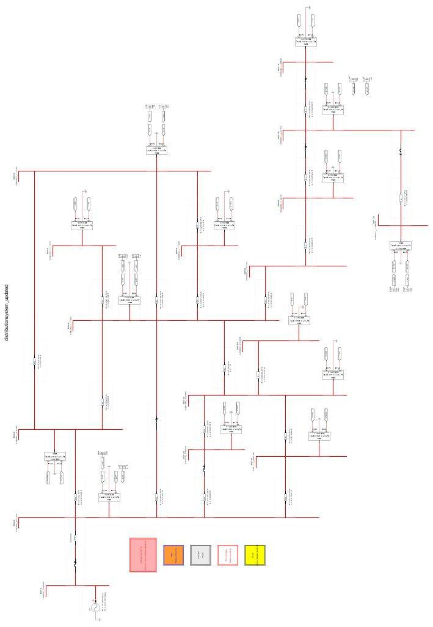

Fig.33. RSCAD model of 16 Bus distribution grid

* + 1. Simulation Results

The state estimation is done considering only 1 PMU measurement at a time. The figures Fig.34 - Fig.35- shows the estimation results for a particular loading schedule and the figure Fig.36 - Fig.37 shows the evolution of the state variables over the simulation time of 5 min.



Fig.34.Estimation of Voltage Angle



Fig.35.Estimation of Voltage Magnitude

Voltage_Angle_Estimation_time

Fig.36.Evolution of estimated voltage angle over time

Voltage_Magnitude_Estimation_time 

Fig.37.Evolution of estimated voltage magnitude over time

1. Conclusions

Through this thesis a real time simulation platform for monitoring power systems is developed. The monitoring platform developed incorporates 4 commercial PMUs of Alstom and one in-house developed prototype of dynamic phasor PMU based on NI hardware. With the developed platform varied kinds of power systems can be simulated in RTDS and the measurements can be acquired in real time. In this thesis the classical measurements are acquired through scripts in text files. The analog signals corresponding to the bus voltages are sent to the PMUs via the GTAO card of RTDS in real time for generating the phasors. As the input range of the commercial PMUs don’t match with the output of GTAO a scaling and amplification devices are used. The synchrophasors published by the PMUs are then collected by virtual phasor data concentrator set through OpenPDC which is an open source software.

A software platform for control center applications is proposed. It is designed to be able to aggregate measurements of different formats and make it available to the application through database. In this thesis MySQL database is used. The platform allows a plug and play design of applications. General guidelines for designing the control center applications are presented. An example of online state estimation algorithm is implemented as a control center application. This application is chosen because the state estimation is an integral part of any advanced monitoring systems as it gives the best situational awareness. A test case is presented where an online DSSE algorithm is implemented as a state estimator which incorporates PMU measurements and the classical measurements in real time and estimates the states of a 16 bus radial distribution grid.

To test the robustness of the monitoring platform to the losses in communication systems, virtual networks are setup with the help of WANem . A small test is conducted to demonstrate the robustness of OpenPDC to receive synchrophasor data through these networks.

One of the main bottlenecks of the monitoring platform suggested is the acquisition of the Phasor measurements. With the commercial measurements sending 30 measurements per frame depending upon the reporting rate and number of PMUs connected in the network the bandwidth of the communication channels would be pushed at their limits. Problems arise when proper care is not taken in allocating the PMUs for each PDCs. Each PDC instance realized by OpenPDC should be configured to receive phasor measurements only from 2 PMUs.

* 1. Future Work

The developed monitoring platform can be extended to include the SCADA systems. The classical measurements in this thesis is through text files but instead of text files GTNET card can be used to acquire real time measurement in DNP 3 format. Furthermore the developed prototype of signal conditioner is to be built on a printed circuit board.

1. Bibliography

|  |  |
| --- | --- |
| [1] | M. Chenine and L. Nordstrom, "Performance Considerations in Wide Area Monitoring and Control Systems," CIGRE, 2010. |
| [2] | V. Terzija, . D. Cai, . A. Vaccaro and . J. Fitch, "Architecture of wide area monitoring systems and," CIGRE, 2010. |
| [3] | M. D. Hadley, . J. B. McBride, . T. W. Edgar, L. R. O’Neil and J. D. Johnson, "Securing Wide Area Measurement System," Richland, 2007. |
| [4] | IEEE Standards Association, *IEEE Standard for Synchrophasor Measurements for Power Systems,* New york, 2011. |
| [5] | A. G. Phadke and J. S. Thorp, Synchronized Phasor Measurements and Their Applications, Springer, 2008. |
| [6] | IEEE Power Engineering Society, *IEEE Standard for Synchrophasors for Power Systems,* New York: IEEE, 2006. |
| [7] | RTDS, "RTDS Manual". |
| [8] | RTDS, "RTDS Hardware Manual". |
| [9] | Alstom, *Technical Manual Phasor Measurement Unit,* 2012. |
| [10] | Range Commanders Council, *Overview of IRIG-B Time Code Standard,* Cyber Sciences Inc, 2011. |
| [11] | N. F. Macia and V. O. Blackledge, "A Method for Obtaining the Transfer Function of Inverting and Non-inverting Op-amp Circuits Based on Classical Feedback Theory," in *American Society for Engineering Education Annual Conference & Exposition*, 2001. |
| [12] | OpenPDC, "The Open Source Phasor Data Concentrator," 14 November 2013. [Online]. Available: http://openpdc.codeplex.com/. [Accessed May 2013]. |
| [13] | M. Chenine, L. Vanfretti, S. Bengtsson and L. Nordstroem, "Implementation of an Experimental Wide-Area Monitoring Platform for Development of Synchronized Phasor Measurement Applications," in *IEEE Conference* , 2011. |
| [14] | OpenPDC Codeplex, "Problem with AdoAdapters configuration of OpenPDC 1.4 SP2," 14 November 2013. [Online]. Available: http://openpdc.codeplex.com/discussions/285047. [Accessed August 2013]. |
| [15] | TATA Consultancy Services, "WANem 2.0 Wide Area Network Emulator," TATA Consultancy Services, 2008. |
| [16] | J. Liu, J. Tang, F. Ponci, A. Monti, C. Muscas and P. A. Pegoraro, "Trade-Offs in PMU Deployment for State Estimation in Active Distribution Grids," *IEEE Transactions on Smart Grid,* vol. 3, no. 2, pp. 915-924, 2012. |
| [17] | V. Terzija, G. Valverde, D. Cai, P. Regulski, V. Madani, J. Fitch, S. Skok, M. . M. Begovic and A. G. Phadke, "Wide-AreaMonitoring,Protection, and Control of Future Electric Power Networks," *IEEE Proceedings,* vol. 99, no. 1, pp. 80-93, 2011. |

1. Appendix
   1. Commissioning GPS Unit P598
      1. Power Supply

The nominal and operational ranges of the auxiliary power supply with a quiescent burden of 5W is given in the table (Table.2).

Table.2.GPS Auxiliary Supply Ratings

|  |  |  |  |
| --- | --- | --- | --- |
| **Nominal Supply ratings** | | **DC**  **Operating Range** | **AC**  **Operating Range** |
| **DC** | **AC(RMS)** |
| 24- 48 V | [-] | 19 – 58 V |  |
| 48 – 125 V | 35 – 100 V | 37 – 150 V | 30 – 110 V |
| 110 -250 | 100 – 240 V | 87 – 300 V | 80 – 265 V |

* + 1. Checks and Commissioning steps with GPS energized

1. Adjust date and time for local time
   1. Set in HMI:DATE TIME CONFIG 🡪 UTC Offset = 2:00 after entering the level 1 password.
   2. Press Enter key and exit DATE TIME CONFIG.
   3. Save settings
2. On power up P594 Healthy LED should be ON and Sync LED will be lit after 15 min of power up once the antenna finds more than 4 satellite .
3. 1 pps connection to P847 PMU.
   1. Connect fibre output TX1 to P847.
   2. Set in HMI : FIBRE CONFIG 🡪 Fibre Output 1 = 1PPS Sync'd.
   3. Ensure SYNC LED is illuminated.
   4. Check if P847 (PMU)reccognizes the signal
4. IRIG-B connection to P847 PMU.
   1. Connection through BNC connector
      1. Connect un-modulated output SK1 to P847 through 50 ohm coaxial cable.
      2. Set in HMI : IRIG-B CONFIG 🡪 BNC O\P mode 1 = Unmodulated.
      3. Check if P847 (PMU)reccognizes the signal
   2. Commissioning and Testing of MiCOM P847
      1. Tests with PMU de-energized
5. CT shorting contacts tested by continuity tester.refer manual for the exact CT shorting terminal numbers.
   * 1. Tests with PMU energized

The nominal and operating voltage of the auxiliary power supply is given in the table (Table.3) with a burden of 11 W.

Table.3.PMU Auxiliary Supply Ratings

|  |  |  |  |
| --- | --- | --- | --- |
| **Nominal Supply ratings** | | **DC**  **Operating Range** | **AC**  **Operating Range** |
| **DC** | **AC(RMS)** |
| 24- 48 V | [-] | 19 – 58 V |  |
| 48 – 125 V | 35 – 100 V | 37 – 150 V | 30 – 110 V |
| 110 -250 | 100 – 240 V | 87 – 300 V | 80 – 265 V |

* + 1. Preliminary checks and tests

The following steps should be followed to commission and configure the PMU.

1. Check watchdog contacts after energizing.
2. Check LCD display for right amount of contrast.
3. Set the date and time.
   1. Remove the battery isolation strip from under the lower access cover.
   2. Connect the IRIG-B from GPS unit through a coaxial cable of type RG59LSF with BNC connector .
      1. After connection check in HMI [0805]:Date& Time 🡪 IRIG-B Status = Active.
   3. Correct the time in GPS to show the local time.
      1. After the adjustment, check in HMI [0801]:Date & Time 🡪 Date \Time
      2. Enter manually the year in this cell as IRIG-B doesnt give the year information.
4. Check LEDs
   1. All LEDs should flash 'yellow' followed by 'green' on power up.
   2. With power up if the trip, alarm LEDs are not ON then individual testing of LEDs is not required if not then it should be done(exception-alarms related to communication might still be ON).
   3. To check alarm and out of service LEDs.
      1. Set in HMI [0F0D]:Commission Test 🡪 Test Mode = Contacts blocked.
      2. And check alarm and out of service LEDs if they are ON.
   4. To check user programmed LEDs.
      1. Set in HMI [0F10]:Commission Test 🡪 Test LEDS = Apply Test.
      2. And check all 18 LEDs glow 'yellow'.
5. Check output relays.
   1. Check in HMI[0F0D]: Commission test 🡪 Test Mode = Blocked.
   2. Select the relay to be checked by energizing appropriate relays.
      1. Set in HMI[0F0E]: Commission test 🡪 Test Pattern = 1(for relay 1).
   3. Check for continuity with a continuity tester accross the terminals for initial relay state.
   4. Operate the relay.
      1. Set in HMI[0F0F]: Commission test 🡪 Contact Test = Apply test.
      2. Check for continuity.
      3. Set HMI[0F0F]: Commission test 🡪 Contact Test = Remove test.
6. Return the IED to service after these checks on I\O terminals are done.
   1. Set in HMI[0F0D]: Commission test 🡪 Test Mode = Disabled.
7. Configure CT terminals
   1. Set frequency
      1. Set in HMI[0009]: System Data 🡪 Frequency = 50.
   2. Set CT ratio
      1. Set in HMI[0A07]: CT & VT Ratios 🡪 CT1 A Phase = CT\_ratio.
   3. Set the source of current ,whether its the primary or secondary current of CT which is fed into PMU.
      1. Set in HMI[0D02]: Measurement Setup 🡪 Local Values = Primary or Secondary.
   4. Apply current at the terminal pairs given in the manual for which the CT ratio was defined.
   5. Measure the value through multimeter.
   6. Verify this value with the calculated value from the PMU.
      1. Check in HMI[02'01']: Measurements1 🡪 'IA' Magnitude ='Multimeter readings' or 'Multimeter readings' \* CT\_ratio' if Measurement Setup🡪 Local Values = Secondary or Primary respectively .
8. Configure VT input terminals.
   1. Once the frequency is fixed follow the same procedures as for the CT configuration.
9. Configure ethernet communication.
   1. Should be set through MiCOM S1 Agile explained in the manual in section 6.4.1.
   2. After setting up through PC check in HMI: IED configurator.
      1. List of hardware for testing
10. PMU
11. GPS unit, antenna with the coaxial cable with BNC termination at the GPS unit.
12. Multimeter
13. AC voltage and current signal generators to simulate VT and CT secondary side voltage and current.
14. AC or DC power source for energizing the GPS and the PMU.
15. PC with MiCOM S1 Agile installed.
16. Cables and connectors
    1. M4 screws and ring terminals.
    2. CT Connections.
       1. Wire size 2.5 mm2
       2. Connect with m4 screws and ring.
    3. For Auxiliary power supply
       1. Wire size 1.5 mm2.
       2. Connect with m4 screws and ring.
    4. IRIG-B connection
       1. BNC Connector with 50 ohm Characterisitic impedance.
       2. Coaxial cable of type RG59LSF.
    5. 1pps Connection
       1. Fibre optic connection with ST type connector.
       2. Fibre optic cable of 50\125 μm or 62.5\125 μm -850nm.
    6. EIA(RS)232 front port connection to interface with PC.
       1. Port located behind the lower acces cover of PMU.
       2. Multi core communication cable with D type metal shelled male plug termination at the PMU end.
    7. RJ45 metallic ethermnet connection cable.
    8. Installation procedure for OpenPDC

The following procedures have to be followed for installing up OpenPDC.

1. Download the “Synchrophasors.Installs(rev2).zip ” file from the OpenPDC download section from the following link http://openpdc.codeplex.com /releases/view/98475
2. Extract the files and run the Setup.exe.

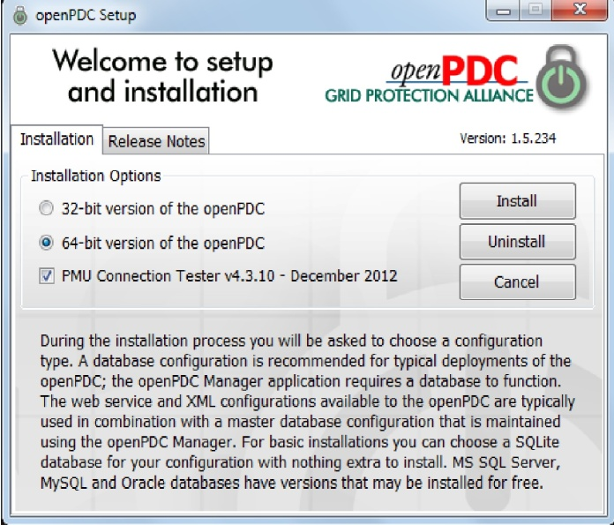

Fig.38.OpenPDC Setup Window

1. Select appropriate version depending on the PC ratings and click “Install”
2. Follow the installation procedure given in the link below until the window “Setup a Database” pane in the Configuration Setup Utility window is reached (Fig.39).Select MySQL and proceed to the next stage.

<http://openpdc.codeplex.com/wikipage?title=Getting%20Started&referringTitle=Documentation>.

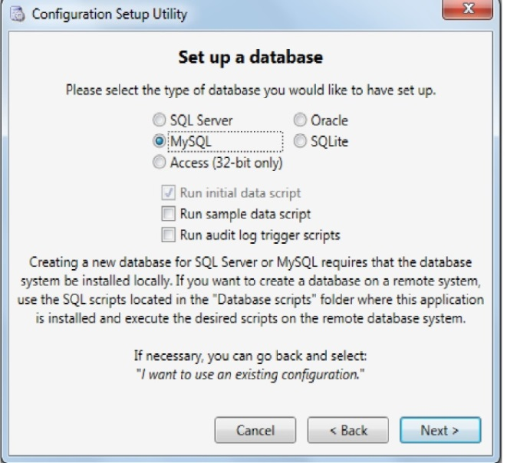

Fig.39.Configuration setup utility window

1. Set Admin user name as “root” and Admin password as the password set while installing MySQL.

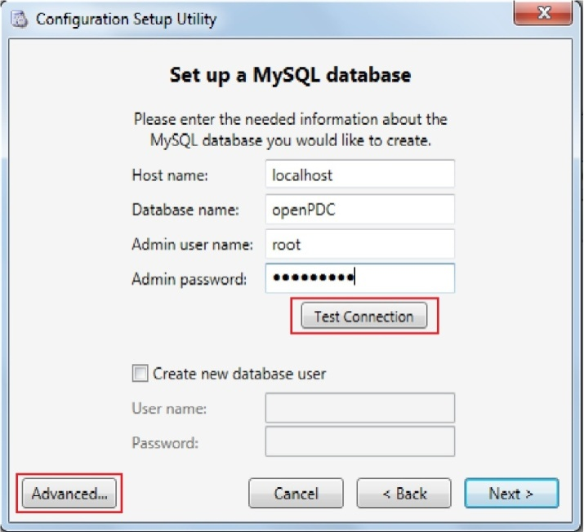

Fig.40.Satabase connectivity window

1. Click “Advanced…” for setting up the database connector version and mysql.exe path.

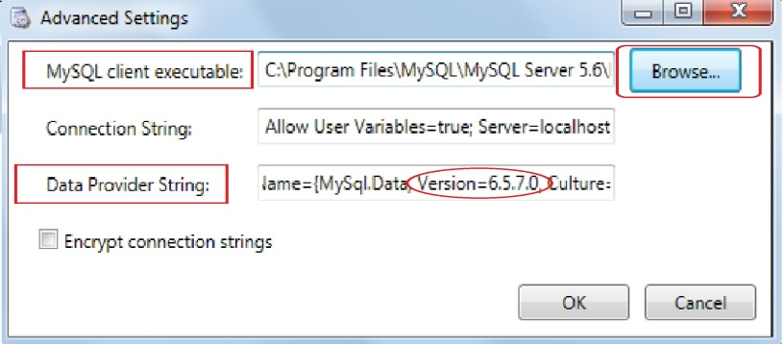

Fig.41.Advanced database connectivity settings

1. Set the path of the mysql.exe using the browse button .
2. The default path in windows would be C:\Program Files\MySQL\MySQL Server 5.6\bin\mysql.exe
3. Set the version as highlighted by a red circle . This number corresponds to the version of the NET Connector .
4. OpenPDC is not compatible with the latest version of MySQL .NET Connector. It is recommended that NET Connector 6.5.7.0 version be installed.
5. After setting the advanced settings click the “Test Connection” as highlighted in fig. If the advanced settings were correctly set then a conformation window would pop up as in fig.

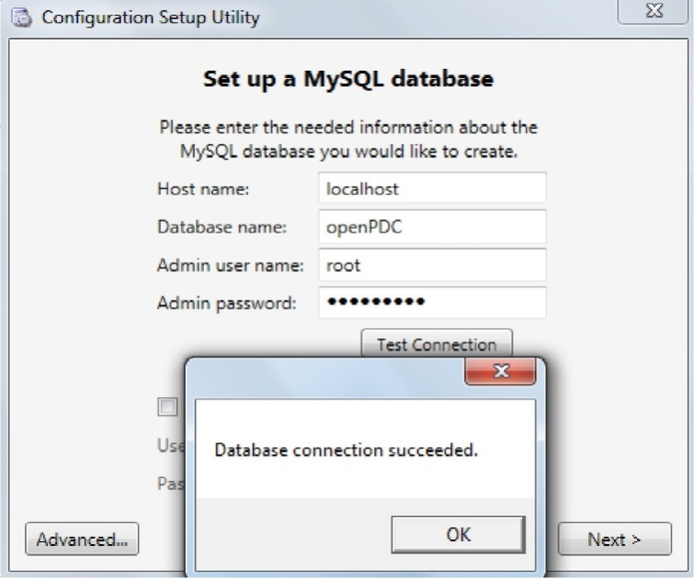

Fig.42.Database connectivity test

1. Follow the rest of the setup procedures as given in the link in the step 4 to setup the OpenPDC and PMU Connection tester.
   1. Configuration of Output Adapters in OpenPDC

First the output adapters have to be configured which would be unique for each input adapter as described in section. After which the input adapters are configured to use the unique output adapter during its configuration. The configuration steps are given below.

* + 1. Configuration of Ado Adapters

1. Open OpenPDC Manager
2. Navigate to Outputs 🡪 Historian
3. Set unique acronym of the format “PMU\_Name\_DB”
4. Set
   1. Type Name : “AdoAdapters.AdoOutputAdapter” .
   2. Assembly Name : “AdoAdapters.dll”.
   3. Connection String : Specifies the following parameters.
   4. DataProviderString : The database Connector.
   5. Connection Type , Adapter Type : Specifies which kind of database is used (egMySQl, SQL, Access etc).
   6. DbConnectionString : Specifies the communication protocols,database name and its access details

An Example of a connection string is as given

DataProviderString={AssemblyName={MySql.Data, Version=6.5.7.0, Culture=neutral, PublicKeyToken=c5687fc88969c44d};ConnectionType=MySql.Data.MySqlClient.MySqlConnection;AdapterType=MySql.Data.MySqlClient.MySqlDataAdapter};DbConnectionString={server=localhost;port=3306;database=openPDC;uid=root;pwd=acs-admin};TableName = PMU\_Data ; KeyFieldName = Measurement\_Key ; TimestampFieldName = Time\_Stamp; ValueFieldName = Value; timestampFormat=yyyy-MM-dd HH:mm:ss.fff

This means that using a NET connector 6.5.7.0 and the MySQL adapters the output adapter of openPDC connects itself to the MySQL database. It stores the data received from the input adapter into a table named “PMU\_Data” which is already setup in the database . The measurement key of the measurement will be stored under the column “Measurement\_Key”, the value of the measurement would be stored under “Value”, Time stamp under “Time\_Stamp” with a time stamp format of “yyyy-MM-dd HH:mm:ss.fff”.

1. Click “Save” then “Enable” and “Initiate”
   * 1. Configuration of CSV Adapters
2. Open OpenPDC Manager
3. Navigate to Outputs 🡪 Historian
4. Set unique acronym of the format “PMU\_Name\_CSV”
5. Set
   1. Type Name: “CsvAdapters.CsvOutputAdapter” .
   2. Assembly Name: “CsvAdapters.dll”.
   3. Connection String: Full path where the .csv file needed to be stored.
      1. Eg: FileName=C:\Users\acs-admin\Desktop\Sadu\PMU\_data.csv;
      2. Note : PMU\_Data.csv is automatically generated.There needn’t be a CSV file setup before hand.
      3. Configuration of Concentrate output streams
6. Open OpenPDC Manager.
7. Navigate to Outputs 🡪 Concentrator Output Streams.
8. Set
   1. Acronym : “PDC\_number” E.g PDC\_1 where 1 stands for the seriel number assigned to the PDC in the same hierarchical level of PDCs.
   2. ID Code
9. Select the mode of streaming either by TCP or UDP by setting up the communication channel properties.
   1. For TCP
      1. Check Force IPv4 check box.
      2. Set the port number.
   2. For UDP
      1. Check Force IPv4 check box.
      2. Set the IP addresses of the destination PCs to which the stream has to be sent.
10. Set
    1. Nominal Frequency
    2. Frames per second
    3. Lag and lead times
       1. Start by setting both of them at 20 and subsequently reduce it for better performance.
    4. Under Advanced Properties
       1. Set
          * Time Resolution 5500000
       2. Check
          * Auto Start Data Channel
          * Allow Sorts by Arrival
          * Auto Publish Config Frame
          * Ignore Bad Timestamps
          * Perform Timestamp Reasonability Check
       3. Uncheck
          * Allow Preemptive Publishing
          * Use Local Clock as real-time
11. Click “Save”.
12. Click “Initiate”.
13. Check “Enable” for initiating the stream.
    1. Configuration of Input Adapters

Configuring the input adapters requires two main steps.

1. Retrieve the connection file (.PMUConnection) and the Configuration file (.xml) of the PMU using the PMU Connection Tester.
   1. Open PMU Connection Tetser
   2. Under TCP tab
      1. Set
         * Host IP : IP Address of the PMU (For NIcRIO :137.226.160.100)
         * Port : Port Number through which the synchrophasors are published (e.g. 4712)
   3. Under Protocol tab
      1. Set
         * Communication protocol used by PMU from drop down menu
         * Device code given by the manufacturer
   4. Click “Connect”
   5. Save the connection and configuration files.



Fig.43.PMU Connection Tester





Fig.44.Saving the Configuration and Connection files

1. Configure Input Adapter in OpenPDC
   1. Open OpenPDC Manager
   2. Navigate to Devices 🡪 Input Wizard
   3. Load the Connection file obtained from PMU Connection Tester in the “Connection File” field.
   4. Click “Next”
   5. Load the configuration file similarly.
   6. Select the Output Adapter in the drop down menu of “Historian”.
   7. If the input adapter is to be configured for receiving the stream of measurements from a remote PDC then
      1. Check the “Connection is to Concentrator” checkbox
      2. Specify the PDC Acronym as defined while setting up the concentrated output stream
   8. Click “Next”
   9. Name the Input Adapter in the format : “PMUName\_DeviceNumber”

e.g. “MiCOM\_P847\_1”: Alstom PMU MiCOM P847 with the device number 1

* 1. Click “Finish”
  2. Setup procedure of MySQL

1. Download and run MySQL Installer 5.6.15 from the link :

[*http://dev.mysql.com/downloads/installer/*](http://dev.mysql.com/downloads/installer/)

1. Check during installation if MySQL NET connector is of version 6.5.7 or lower.
2. If it is not then after the completion of the installation download and install MySQL NET connector 6.5.7 or lower manually from the link : [*http://dev.mysql.com/downloads/connector/net/*](http://dev.mysql.com/downloads/connector/net/)
3. Note down the password set as they would be required by the applications which need the data from the database.
   1. Database configuration

MySQL has to be installed before the installation of OpenPDC.While configuring OpenPDC the database instance named “openpdc” automatically gets created as the SQL queries required for that are provided within the installation package of OpenPDC.The database instance “openpdc” just has the basic tables required for OpenPDC software to run. For storing the phasor measurement data into the database, custom tables have to be created. Once created , the Ado adapters of OpenPDC can be configured to store the data into that particular table. The procedure to setup a table in database is given in the following steps.

1. Open MySQL Workbench
2. Select the database instance under “SCHEMAS” to which the table is to be added.

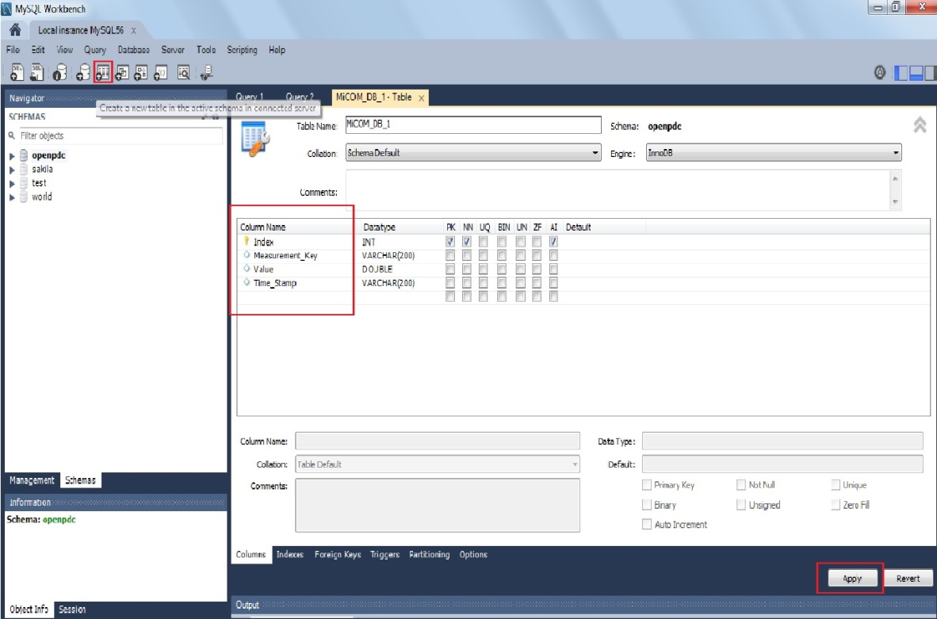

1. Click the icon on the top to create a table.
2. In the table pane on the right initialise the table name and column names of the table and assign the data type of each coloumn and click “Apply”.
3. Alternatively the following SQL query could be run to create the table.

CREATE TABLE `name\_of\_database`.`name\_of\_table` (

`Index` INT NOT NULL AUTO\_INCREMENT,

`Measurement\_Key` VARCHAR(200) NULL,

`Value` DOUBLE NULL,

`Time\_Stamp` VARCHAR(200) NULL,

PRIMARY KEY (`Index`));

Where Index,Measurement\_Key,Value and Time\_Stamp are the names of the coloumns and the data type of the data stored in these coloumns are specified in blue.INT for integers, VARCHAR for characters of variable length and DOUBLE for numeric double data.

Once the table is created in the database , the connection string of the Ado Adapters should be set to store the data into this particular table specifying which data to be stored under which coloumn.

* 1. Trouble Shooting
     1. PMU connection tester doesn’t stream Synchrophasors.

Both Open PDC and PMU connection tester cannot be run simultaneously. Care should be taken to stop the OpenPDC service before starting the PMU connection tester.Make sure that another PMU connection tester is stopped from trying to stream the synchrophasors from the same PMU.This can be done by doing the following

1. Type “services.msc” in the search field of the “Windows” button

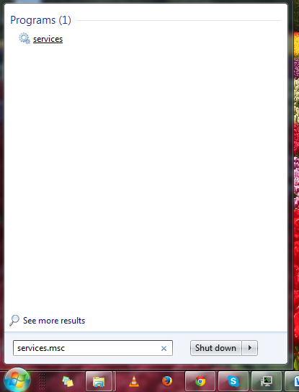

Fig.45.Services

1. Click on  and search for OpenPDC service and stop it as shown below

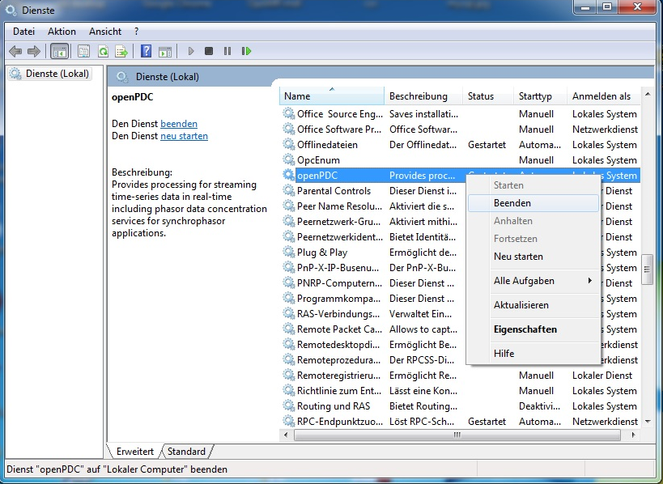

Fig.46.Stopping OpenPDC service before starting PMU connection tester

1. If PMU connection tester still doesn’t stream then check the settings tab and set the status of “force IPV4” as “True”.
2. If it still doesn’t work then check the firewall settings of the computer and disable all the firewall security settings.
3. If it still doesn’t work then reinstall the PMU connection tester. ☺
   * 1. OpenPDC Doesn’t stream synchrophasors
4. Check if the colour of the circle corresponding to Current node is Red or Green. If it is red as shown in figure then the OpenPDC service has to be started from “services.msc”

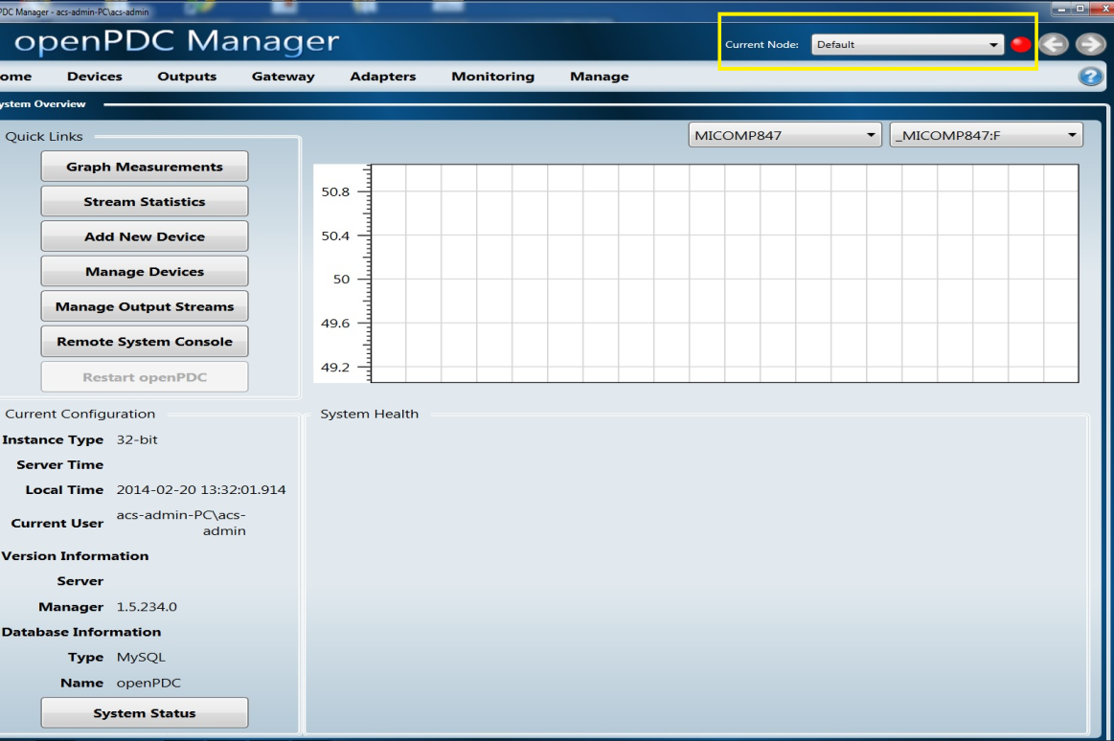

Fig. 47. Check the Current Node Status (Red or Green)

1. If it is green and still the synchrophasors are not streamed, then check if the OpenPDC is run on another PC in the same network, which is trying to stream the synchrophasors from the same device. By default OpenPDC is designed to have a one to one interaction with the PMUs. It means that 2 or more OpenPDC instances running in multiple PCs cannot stream the synchrophasors from the same device.

Therefore either the services of the OpenPDC trying to stream the synchrophasors from the same device should be stopped (as per Section.9.8.1) or allocation of PMUs should be done so that not more than one OpenPDC instance is configured to stream the synchrophasors from a particular PMU.

* + 1. OpenPDC Manager doesn’t start and gives error messages

1. Open OpenPDC Console and check for error messages .
2. If the error message as shown below

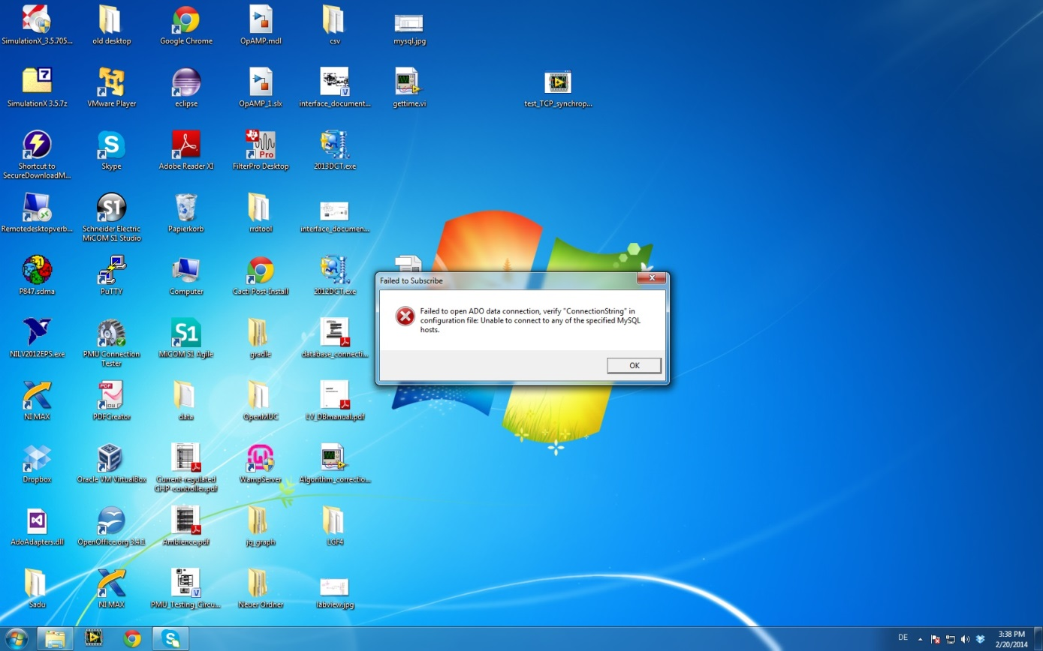

Fig.48.Ado error message

Then start the MySQL56 service in “services.msc”.